ternational Association of Security Professionals

e Official Publication of AL

**larch 2004**

eLcome to le uionpeRFUL

**ORLD OF** EIIC

PLUS

THB 081 OmniLOCK OPZOOO, CVCLB  
CHRoniCLBS: hbrlbv Davioson ano  
thb muiacLB man, sbfb cobibo CHanGinG

(Pant 3)

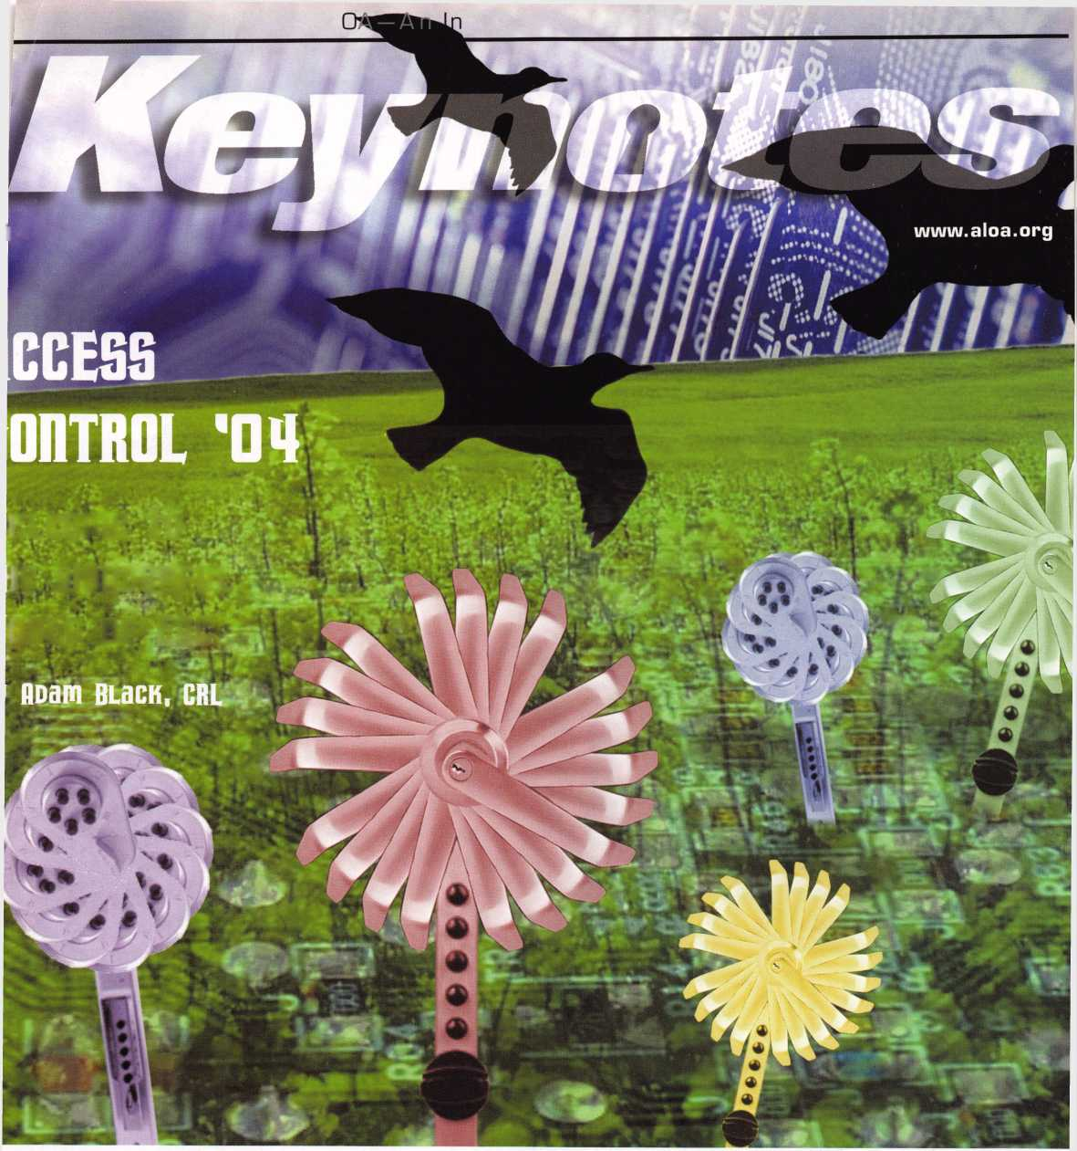

BACK

**enter**

USD

PLUS TAX

**QUICKER PAYBACK**

**strattecXL**

**CODE-SEEKER**

**Part #708884**

**f ONE SOURCE. MANY SOLUTIONS**

introducing **CODE-SEEKER.**

NOT JUST A TOOL A MONEY-MAKING MACHINE.

**FREE UPGRADES in 2004!**

**• An UPGRADE SUBSCRIPTION of only $499 per year in 2005 and 2006!**

**» OFFSET THAT UPGRADE FEE.**

**Get $1 credit toward the subscription fee for every STRATTEC transponder key purchased through an**

**authorized STRATTEC distributor! (Up to $499; no cash back value.)**

**’ 24-7 customer service and support!**

**’ A name you can trust in automotive lock technology!**

**call** 414**-**247-3333 **to order.**

**ASK FOR CODE-SEEKER SALES.**

©2004 STRATTEC SECURITY CORPORATION All rights reserved

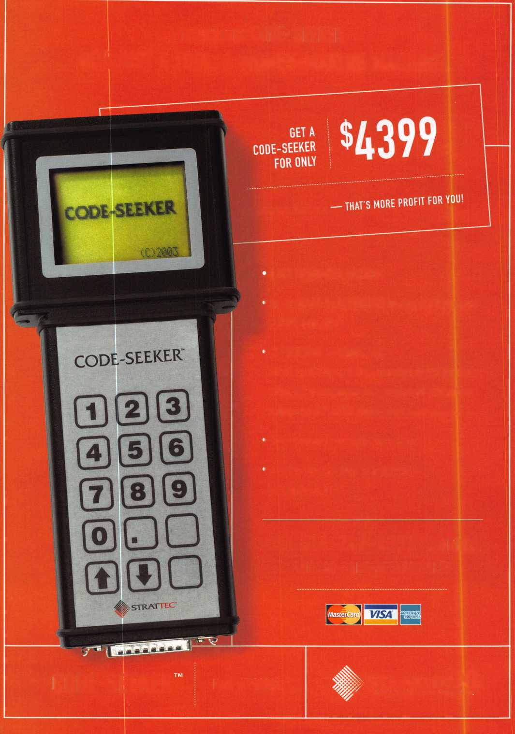

**PROFIT FROM TECHNOLOGY.**

**FORD TRANSPONDER KEYS FROM STRATTEC.**

**STRATTEC**

**FOR MORE INFORMATION, CONTACT YOUR DISTRIBUTOR**

DEMAND IT

Need information in a hurry?  
Use ALOA’s Fax On Oemand service.

■ ■ f|

I I

Just call 310-575-5074 and receive:

1. ALOA Index of Documents
2. Becoming a Locksmith (lpg)
3. Locksmith Career Summary (3pg)
4. Locksmith School List (2pg)
5. ACE Gass Schedule (8pg)
6. Certification lnformation(3pg)
7. PRP Category List (lpg)
8. ALOA Membership Application(2pg)
9. ALOA List of Benefits (lpg)
10. Scholarship Application Form (lpg)
11. ALOA Video Library Order Form (lpg)
12. ALOA Membership Items Order Form (lpg)
13. Safe & Vault Technicians Association Member

Application/Subscription Form (2pg)

1. ALOA Chapter Roster (3pg)
2. Legislative Action Network (2pg)
3. Legislative Action Network Newsletters (lpg)
4. Various State Laws (lOpg)
5. Industry Position Pager (1 pg)
6. Current Legislative Action Network Newsletters (lpg)
7. Board of Directors Nomination Form (2pg)
8. ALOA Convention Registration
9. ALOA Board Expense Reimbursement &

Request Form

ALOA continues to provide you with this  
and other great benefits and services!

310-515-5014

Advertise with Weatherproof Safety Labels!

your

ng card on

every door you  
service! Keep  
your name in front  
of every customer

with these Durable,

able Labels

& Order Today

55-6322

**(Actual Label Size 1 1/2x4 1/2)**

Professional Business Products

**ALOA Associate Member**

Check out our competitive prices on Invoices with two color ALOA  
logo, Repair Tags/Claim Checks, Business Cards, Door Hangers,  
Shirts, Hats, Pens, Key Tags, Magnets.

[www.professionalbusinessproducts.com](http://www.professionalbusinessproducts.com)

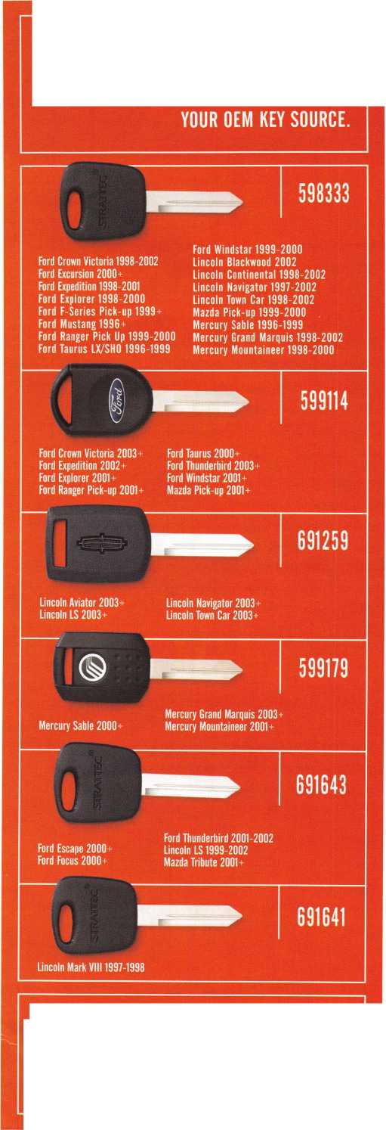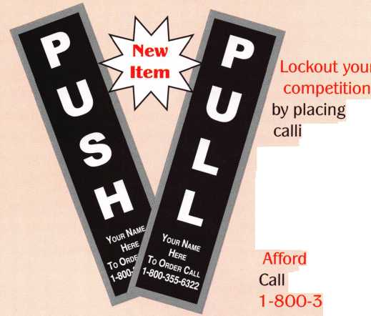

|  |  |  |
| --- | --- | --- |
| p r e | s i d | e n t i a 1 |
| v i | e w | point |

Dear members,

I have to start off with a little presidential business by reminding those  
unpaid members that this is the last issue of Keynotes that you will  
receive until dues are paid. Who would want to miss out on the exciting  
and informative articles that grace this magazine each month? I am  
pleased that renewals remain at the levels that they were at this time last  
year. That is a positive reflection that the majority of the membership  
feel that the legislative assessment was a much-needed and positive  
action. I am optimistic about what the legislative funds will help us

accomplish. The equivalent of contributing the cost of two extra common keys a month can bene-  
fit our membership greatly. If any of us could single-handedly undertake something as huge and  
far-reaching as ALOA's legislative efforts, there would be no need for this vital and difficult effort.  
Thanks for teaming up with us - I assure you that, in the end, your decision to support ALOA will  
pay you back several times over.

I must next make a plug for the two most important shows for our collective organization, and for locksmiths and safemen in general. For you stragglers, there is still time to get in on the action at SAFETECH 2004 in Reno, NV, at the end of this month. But hurry, because you don't want to miss this event. I am planning on sitting for the Safeman's PRP to test my knowledge in a field that I think I am pretty good at. Well see what I really know.

This year, the March issue is dedicated to access control. This is an area that we are constantly having to battle for, in order to ensure our right to perform this work. I am not an access control expert, but I have realized how important it is to offer this service and employ people who are experts. Many locksmiths are hesitant to get into this field (as I certainly would be), because it is unfamiliar to them. A great way to start is the way that my company did. We hooked up with alarm companies who had no expertise in the areas of locking hardware. So, we used our expertise and were soon subcontracting the installation of electric strikes, mag locks and electri­fied exit devices; then, the alarm companies would "tie in." This is the hard part. It wasn't long before we were doing our own systems.

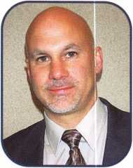

Read on and learn!

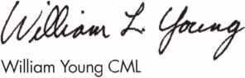

Keynotes • March 2004



Get It...  
Together

Get ready for ALOA 2004 - the biggest security event in the world! ALOA will land in Baltimore's famed Inner Harbor to stage classes, workshops and exhibits that will help you shine in today's marketplace.

*\%L.*

fc-ftt-TtWOKE,

get it... together

The ALOA Convention and Security Expo • Baltimore Convention Center • July 19-25, 2004  
(800)532-ALOA(2562) • [convention@aloa.org](mailto:convention@aloa.org) • [www.aloa.org](http://www.aloa.org)

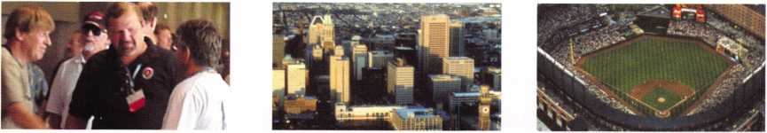

f

t

r

e

s

e

a

u

Access Control

**departments**

Executive 5

Applicants 6

Calendar 8

Core 10

Legislative Update 38

Classifieds 40

Associate

Members 42

|  |  |  |  |
| --- | --- | --- | --- |
| r |  |  |  |
|  | **Ad Index** |  |  |
|  | Strattec Inside Front Cover | |  |
|  | Professional Business Products | 1 |  |
|  | Lockmasters | 7 |  |
|  | Clearstar | 9 |  |
|  | interkey/ELF | 9 |  |
|  | Videx | **..11** |  |
|  | Ftinge Doctor | .15 |  |
|  | Turn 10 | .27 |  |
|  | Adesco | .29 |  |
|  | A&B Safe | ...41 |  |
|  | Hickok Back Cover | |  |
| **L** |  |  | 1 |



The WONDERFUL WORLD OF EAC

I can still remember the first time I saw it. The fear in my eyes, the sweat on my brow ... I was tormented. I was working on a lock, and my worst nightmare had come to my conscious realm: a "wire" was attached to the lock!



By Adam Black, CRL

Greg's Corner: Don't Drop The Lock!

As I was taking the last screw out holding the Von Duprin 99 exit device through door to the OSI OMNILOCK OP2000, I received a call. I took my hand off the OMNILOCK to answer the call. Turning back to the job at hand, I finished removing the last screw. Most of you can guess what happened next. It did not survive! The buttons scattered around the impact site. I looked at my customer and back at the now broken lock on the ground. He was stunned, and the only thing he could say was, "Its Monday."

By Greg Perry, CML, CPS

Safes

**24**

Changing Safe Combinations (Third and Final Installment of Series)

Before you begin changing combinations, you must first understand the rotations of the dial and what you accomplish when turning the dial. This will not only enable you to change the combination, but also allow you to explain the dialing sequence to the customer, which will save a return trip in the event the customer doesn't under­stand the dialing procedure.

By Jim Hancock, CRL

Automotive Locksmithing

Transponders — Kicking The CAN

From the first transponder-equipped vehicle to hit the road, locksmiths  
have been plagued with the need for tools and instructions on pro-  
gramming these vehicles. Over the last several years, my colleagues  
and I have done our best to keep you informed on this ever-changing  
technology; up till now, this evolved around the introduction and use  
of aftermarket programming tools.

By Tom Seroogy

**30**

Visit our website at [www.aloa.org](http://www.aloa.org)

**executive**

Volume 50, Issue 3



Additional contact information for the ALOA Board and most Keynotes authors is  
available through "Locksmith Search'" on the ALOA Web site- [www.aloa.org](http://www.aloa.org) or by  
contacting the ALOA office at 3003 Live Oak Street; Dallas, TX 75204; (800)532-2562;  
FAX (214)827-1810; e-mail [aloa@aloa.org](mailto:aloa@aloa.org).

|  |  |
| --- | --- |
| **Editor**  Jim DeSimone | [editor@aloa.org](mailto:editor@aloa.org) |
| **Technical Editor**  David Lowell, CML, CMST | [david@aloa.org](mailto:david@aloa.org) |
| **Art Director**  Betty Henderson | [betty@aloa.org](mailto:betty@aloa.org) |
| **Advertising Sales**  Kim Hammond | voice: 817-645-6778  Fax: 817-645-7599 e-mail: [adsales@aloa.org](mailto:adsales@aloa.org) |
| **Executive Director**  Charles W. Gibson, Jr., CAE . | [charlie@aloa.org](mailto:charlie@aloa.org) |
| **Convention & Meetings Manager**  Jo Anne Mims [joanne@aloa.org](mailto:joanne@aloa.org) | |
| **PRP/Education Manager**  David Lowell, CML, CMST | [david@aloa.org](mailto:david@aloa.org) |

Operations/Membership Manager

Mary May [mary@aloa.org](mailto:mary@aloa.org)

Government Relations Manager

Paul Kanitra [paul@aloa.org](mailto:paul@aloa.org)

IT Operations Manager

Greg Jackson [greg@aloa.org](mailto:greg@aloa.org)

Comptroller Kathy J. Romo

Membership Coordinator Shelly Jett

Convention & Meetings Assistant Karen Lyons

PRP/Education Coordinator Esperanza Rodriguez

Accounting Coordinator Stephanie Brothers

Mail Room Coordinator Kevin Wesley

Receptionist Bryan Dease

|  |  |  |  |
| --- | --- | --- | --- |
| **Contributors**  Jerome Andrews, CML | Ray D'Adamo, CML | AJ. Hoffman, CML | Greg Perry, CML,CPS |
| Paul Chandler, CRL | Sal Dulcamaro, CML | Jeff Nunberg, CML, CMST | Tom Seroogy |
| Claire Cohen, CML | Billy Edwards, CML | Randy Simpson, CML | Charles Stephenson, CPS |
| Brian Costley, CML, CMST | Dan Graffeo, CRL,CMST | Robert Stafford, CML | Dennis Watanabe, CML, CMST |
| Eric Costley, CRL | Jim Hancock, CRL | Dave Thielen, CML |  |

**Mission Statement:** The Associated Locksmiths of America, Inc. is dedicated to enhancing the professionalism, education and ethics among locksmiths and those in related sectors of the physical security industry. With approximately 10,000 members in the United States, Canada and the freeworld, ALOA is poised to help members obtain the knowledge, the strength, and the confidence to perform their role in the physical security field with pride and dignity. But it is only through active involvement and participation that ALOA can fully achieve its potential—and can help members to achieve theirs.

**Policies:** Keynotes® is the official publication of the Associated Locksmiths of America, Inc. (ALOA). Keynotes® acts as a moderator without approving, disapproving, or guaranteeing the validity or accuracy of any data, claim, or opinion appearing under a byline or obtained or quoted from an acknowl­edged source. The opinions expressed by the authors do not necessarily reflect the official views of ALOA. Also, appearance of advertisements and new products or service information does not constitute an endorsement of products or services featured by the Association. The Association does not accept responsibility for the inaccuracy of any data, claim, or opinion appearing in this publication, due to typographical errors on the part of the authors, Association staff or its agents.

**Editor's Note:** This publication is designed to provide accurate and authoritative information in regard to the subject matter covered. It is provided and disseminated with the understanding that the publisher is not engaged in rendering legal or other professional services. If legal advice and other expert assistance is required, the services of a competent professional should be sought.

**Authors' Payment:** Payment for eligible submissions to Keynotes will be based on the following criteria: topic, time spent and past contributions. Authors who regularly submit to Keynotes® are generally paid a higher rate. The latter is especially true of authors who write to fit specific editorial needs and submit said copy by Keynotes® deadlines. As a general guideline: Average payment for a 750 word, business or light' technical article would be $200. Payment for a 1500 word article involving significantly higher time and research efforts would be $400.

Payment will not be offered for articles submitted by ALOA employees or members of the ALOA Board of Directors (unless material is of a technical nature), nor for articles submitted by a company that promote that company's products or services. ALOA reserves the right not to pay for articles sub­mitted by an individual(s) that promote a particular company's products or services.

**Disclaimer:** The Associated Locksmiths of America, Inc., (ALOA), reserves the right to refuse any article for any reason. Additionally, ALOA reserves the right to edit, amend or modify any article submitted for publication in order to preserve technical accuracy, clarity, fairness or grammatical cor­rectness. ALOA will make the best efforts to notify the author of any changes. The extent of ALOA's liability for any article or information contained therein will be a notice of correction or retraction in the next possible issue.

Keynotes® (ISSN 0277 0792) is published monthly except for the combined June/July issue by The Associated Locksmiths of America, Inc., 3003 Live Oak St., Dallas, TX 75204-6186. Telephone: (214) 827-1701; FAX (214) 827-1810; e-mail [aloa@aloa.org](mailto:aloa@aloa.org). Subscription rates for members—$15.00 per year. Periodical class postage paid at Dallas, Texas. POSTMASTER: Send address changes to: Keynotes, 3003 Live Oak St., Dallas, TX 75204-6186. © Copyright 2003, All rights reserved. No part of the contents may be reproduced or reprinted in any form without prior written permission of the publisher.

President

William L. Young, CML  
■ (610)647-5042  
[presidenf@aloa.org](mailto:presidenf@aloa.org)

Secretary

John D. Cannon, CML  
(703) 960-6413  
[secretary@aloa.org](mailto:secretary@aloa.org)

Directors, Northeast

Robert E. Mock  
(856) 8630710  
ned i rector@aloa. org

Peter Sarailian, CRL  
(973)890-9797  
ned i rector@aloa .org

William L. Young, CML  
(610) 647-5042  
nedirector@aioa .org

Directors, Southeast

Tom Gillingham, Jr., CML, CPS  
(615)2640747  
[sedirector@aloa.org](mailto:sedirector@aloa.org)  
Ken Kupferman, CPL  
(813)961-5784  
[sedirector@aloa.org](mailto:sedirector@aloa.org)  
Directors, North Central  
Mark E. Blum, CML, CPS  
(517) 482-5809  
[ncdirector@aioa.org](mailto:ncdirector@aioa.org)

John Soderland, CML, CMST  
(414)327-5625  
[ncdirector@aloa.org](mailto:ncdirector@aloa.org)

Director, South Central

CD Lipscomb, CML, CPS  
(903)874-3522  
scdirector@aloa .org

Directors, Southwest

Gordon R. Racine, CML  
(719) 384-4707  
[swdirector@aloa.org](mailto:swdirector@aloa.org)

Julie McCluney, CRL

(714) 636-5652  
[swdirector@aloa.org](mailto:swdirector@aloa.org)

Director, Northwest

Scott L. Henke, CPL, CPS  
(907) 248-3785  
[nwdirecfor@aloa.org](mailto:nwdirecfor@aloa.org)

Director, European

Hans Mejlshede, CML  
(453)539-3939  
[eurdirector@aloa.org](mailto:eurdirector@aloa.org)

Director, Asian

JoeJ. Lee, CRL  
(215)289-2404  
[asiandirector@aba.org](mailto:asiandirector@aba.org)

Director, Associate

Paul M. Justen  
(800)333-6953  
[asdirecfor@atoa.org](mailto:asdirecfor@atoa.org)

Trustees

[trustees@aba.org](mailto:trustees@aba.org)

Randy Simpson, CML  
(281)2405959

John j. Greenan, CML, CPS (773) 486.2030 •

Dallas Brooks  
(334) 826-8990

Past Presidents

2001-2002 Randy Simpson, CML  
1999-2001 John Greenan, CML, CPS  
1997-1999 Dallas C. Brooks  
1995-1997 David Lowell, CML, CMST  
1993-1995 Breck Camp, CML  
1991-1993 Henry Printz, CML  
1989-1991 Evelyn Wersonick, CML, CPS  
1987-1989 Leonard Passarello, CPL  
1985-1987 Joe Jackman, CML  
1983-1985 Stanley Haney, CPL  
1981-1983 Louis LaGreco, CPL  
1979-1981 John Kerr, RL  
1977-1979 Clifford Cox, CML  
1974-1977 Charles Hetherington  
1972*1974 Gene Laughridge  
19701972 William Dutcher, RL  
1968-1970 Constant Maffey, RL  
1966-1968 Harold Edelstein, RL  
1964-1966 William Meacham  
1962-1964 Robert Racktiffe, CPL  
1960-1962 Edwin Toepfer, RL  
1956-1960 Ernest johannesen

v

Keynotes • March 2004

**5**

CO

**applicants**

for membership



Sitka

Jerold Deppa

AL

Dothan

Clifford Dean

Sponsor: James D. Turner Jr, CML., CPS

Craig McDaniel

Sponsor: Amanda S. Turner

AZ

Phoenix

Steven R. Baldwin

Sponsor: Wayne R. Stuart

Tucson

Chris Campbell

CA

Fortuna

Douglas E. Iverson

Sponsor: Frank C. Cope

Los Angeles

Marilyn Smith

Sponsor: Clyde Smith

Montclair

Bill Sweeney

Sponsor: Edwin J. Vonderbeck

Redwood City

Mark Weiss

Turlock

Daniel J. Beauchamp

Sponsor: Clifford D. Lipscomb CML, CPS

Denver

Jeffry S. Kerns

Sponsor: Carl J. Haynes CRL Sponsor: Charles E. Haas CML

Greeley

Nick Jantz

Pueblo

Keith Burton

Sponsor: James A. Burton CPL

Steamboat Springs

Dennis Glackin

Sponsor: Lee A. Schoeneman CML

CT

Bristol

Thomas Martucci

Sponsor: Michael D. Sigmund

Waterford

Richard J. Gonyo

Sponsor: John G. Sabilia CRL

FL

Jacksonville

Keith E. Rahn

Sponsor: Bruce T. Rahn

Palm Beach Gardens

Todd W. Swain

Sponsor: Ted Damiano

Tampa

Paul Parisi

Sponsor: Ken Kupferman CPL

GA

Atlanta

Jack Wynn

Flowery Branch

Robert Stys

Sponsor: James S. Mayes

Powder Springs

Edward F. Moses II

Sponsor: Irving M. Smoot

IN

Clarksville

Ann M. Walker

Sponsor: Jerry L. Walker

Independence

Nathan K. Rogers

Sponsor: Robert E. Alvis CML

HI

LA

Honolulu

Michael Terry

Sponsor: Earl M. Tokuda

IA

Des Moines

Shaun J. Gumm

Sponsor: David M. Howdle

Chicago

James H. McClinton

Sponsor: William T. Beranek

Mark Cox

DeSoto

Tosha J. Brown

Sponsor: Patrick M. Armstrong

Dekalb

Michele French

Sponsor: Charlotte A. Marx

Shreveport

Neal McMahon

Sponsor: James L. Queen CML

Clifford D. McMahon

Sponsor: Mark A. Queen

Joshua L Queen

Sponsor: James L. Queen CML

MA

Adams

Robert J. Ciempa

Sponsor: Elliott S. Lubin

Canton

John Waldstein

Medway

Clay Jackson

Sponsor: Stephen R. Blanding

Uxbridge

Michael R. Dover

Sponsor: Brian D. Farrar

These applicants are scheduled for clearance as members of ALOA. The names are published for member review and comment within 30  
days of this Keynotes issue date, respectively, to ensure applicants meet standards of ALOA's Code of Ethics. Protests, if any, should be  
addressed to the Membership Department and must be signed. Active Membership applicants (a) have worked in the industry two or more  
years. Allied Membership (AL) applicants are not locksmiths, but work in a security-related field. Apprentice Membership (AP) applicants

have worked in the industry less than two years.

Keynotes • March 2004

MD

OK

WY

Brandywine

Charles Dickerson

Sponsor: Lance A. Edwards

Columbia

Dan Abbott

Sponsor: Carroll T. Croson Jr

Brian Totten

Sponsor: Shaun D. Smith CRL

ME

Glenburn

Michele Perkins

Sponsor: Winfield F. Murray

Springvale

Tammy M. Hilton

Sponsor: Carol A. Atwell

Ml

Brighton

Jason P. Gibson

Sponsor: David E. Burger

Grand Haven

David Vandervelde

Sponsor: William L Young CML

MN

Rockford

Joshua D. Lepowsky

Sponsor: Leo E. Volkmann CRL

MJ

Maplewood

Ernest P. Valcourt

NY

Buffalo

James R. Miller

Sponsor: Christopher M. Griesbaum CRL

OH

Cincinnati

Erik P. Heller

Sponsor: Kenneth J. Puthoff

Darryl Johnson

Sponsor: Michael A. Wells CRL

Ruby J. Breitenbach

Sponsor: David A. Wilburn

Oklahoma City

Ronnie Bada

Sponsor: Mike E. McGrew CRL

Kris Minick Young

Sponsor: Bruce J. Tarbet CML, CPS

PA

Virginia Beach

Stanley Green

Sponsor: Henry W. Raymond

VT

Wilmington

Karen L. Davis

Sponsor: Ernest W. Wright

Malvern

James E. Ploumis

Sponsor: Ronald L. Blevins CML

Rl

WA

Vancouver

Brian Flanagan

Sponsor: Dave J. Werbowski

Charlestown

Robert Jacynowicz

Sponsor: Robert R. Charnley CRL

SD

**Wl**

Fall Creek

Kenneth R. Mason

Sponsor: Kenneth W. Briggs

Douglas

Leslie D. Thompson

Sponsor: Dave Lueras



Arlesey Beds

George McGinlay

Sponsor: Ken Dale

Ashford Kent

Darren Arnold

Sponsor: Ken Dale

Whitley Bay, Tyne &

Peter Price

Stevenage Herts

Robert Gray

Sponsor: Ken Dale

Sioux Falls

Mary P. Horn

Sponsor: Ronald E. Heidzig

TX

Arlington

Hancel Brannon

Sponsor: Clifford D. Lipscomb CMLCPS Dallas

Joe W. Johnson

Sponsor: Mark Caudill CRL

David Gibbs

Sponsor: Randy L Hutchison CRL

David Robison

Sponsor: Randy L Hutchison CRL

Hallettsville

David L. Fagan

Sponsor: Thomas E. Fagan Jr

VA

Alexandria

Deborah Snyder

Sponsor: Gary D. Quick CPL

Jeffery Reagan

Sponsor: Andrew A. Edmunds CML, CPS Richmond

John M. Dietrich

Sponsor: Mark A. Slater

Fond Du Lac

Eugene D. Joyce

Sponsor: John F. Engel CRL

Great Britian

London

Chris Von Cossel



**2004 PARTS CATALOG**

wilh your order. A $10 value.

***Available Now'-***



**LOCKMflSTERS**

INCORPORATED

800.654.0637

lockmasters.com

Keynotes • March 2004

**7**

MAY I APRIL MARCH

upcoming events

|  |  |  |  |
| --- | --- | --- | --- |
| 3 Minnesota Chapter | 11-13 California Locksmith | 12-14 Education Weekend | 26-27 LASA |
| Regular Meeting | Assoc Convention | Minnesota Chapter | San Antonio • Two classes |
| Dave Nissen | Ontario, California | Dave Nissen | Contact Steve Morse |
| [mnchapternews@aol.com](mailto:mnchapternews@aol.com) |  | [mnchapternews@aol.com](mailto:mnchapternews@aol.com) | Phone # 512-353-8615 |
|  |  |  | [topnotch@thrifty.net](mailto:topnotch@thrifty.net) |



7 Minnesota Chapter Regular Meeting Dave Nissen mnchapternews@aol.

16-18 East Coast Regional Locksmith Convention Somerset, New Jersey

24-25 Alabama Locksmith Association Membership Meeting, Dinner, Discussion & Seminars Call 1-800-893-5487



|  |  |  |  |  |
| --- | --- | --- | --- | --- |
| 1 Ok. Master Locksmith Assoc. | 5 | Minnesota Chapter | 19. - 23. LOCKSMITHS CONVENTION 22 | LASA • San Antonio |
| Holiday Inn Select • Tulsa, OK |  | Regular Meeting | ESTREL HOTEL BERLIN | Service and Combo Changing |
| "Defense Against Methods..." |  | Dave Nissen | Tel: +49 030 6831-22522 | Contact Steve Morse |
| Contact: Scott Hancock |  |  | Fax: +49 030 6831-2345 | Phone #512-353-8615 |
| 405-557-7422 | ■Hi |  | mail: [reservierung@estrel.com](mailto:reservierung@estrel.com) | [topnotch@thrifty.net](mailto:topnotch@thrifty.net) |

UPCOMING PRP SITTINGS

|  |  |
| --- | --- |
| 3/11/2004 | Dallas, TX • ALOA  Hope Rodriguez • 800-532-2562x30 |
| 3/14/2004 | Maplewood, MN  Minnesota Chapter of ALOA  Dana Lee, CML • 612-968-4500 |
| 3/21/2004 | Beachwoood, OH • IDN Hardware Sales, Bonnie L. Weston • 734-591-4821 |
| 3/27/2004 | Reno, NV • Safetech 2004  Hope Rodriguez • 800-532-2562x30 |
| 3/28/2004 | Northbrook, IL • Clark Security Products Joan Emrick • 619-718-7308 |
| 4/8/2004 | Dallas, TX • ALOA  Hope Rodriguez • 800-532-2562x30 |
| 4/17/2004 | Somerset, NJ • MLANJ Convention  Bill Timmann, CML • 610-253-2325 |
| 5/13/2004 | Dallas, TX • ALOA  Hope Rodriguez • 800-532-2562x30 |
| 5/15/2004 | Seattle, WA • KDL Hardware Suppply Inc. Julie Pilgrim • 800-926-7716 |

|  |  |
| --- | --- |
| 6/10/2004 | Dallas, TX • ALOA  Hope Rodriguez • 800-532-2562x30 |
| 6/27/2004 | Reno, NV • Clark Security Products Joan Emrick • 619-718-7308 |
| 7/8/2004 | Dallas, TX • ALOA  Hope Rodriguez • 800-532-2562x30 |
| 7/23/2004 | Baltimore, MD  ALOA2004 Convention  Hope Rodriguez • 800-532-2562x30 |
| 8/12/2004 | Dallas, TX • ALOA  Hope Rodriguez • 800-532-2562x30 |
| 9/9/2004 | Dallas, TX • ALOA  Hope Rodriguez • 800-532-2562x30 |
| 10/14/2004 | Dallas, TX • ALOA  Hope Rodriguez • 800-532-2562x30 |
| 11/11/2004 | Dallas, TX • ALOA  Hope Rodriguez • 800-532-2562x30 |
| 12/9/2004 | Dallas, TX • ALOA  Hope Rodriguez • 800-532-2562x30 |



\

You need it When?

**How about now!? :-)**

**Clears tar** ffi

Another Special  
Value-added Benefit to your

ALOA Membership! Click here

f a

[www.clearstar.conn](http://www.clearstar.conn) / ALOA

V/

VJ

**UPCOMING ACE CLASSES**

|  |  |
| --- | --- |
| 3/12-14/2004 | MAPLEWOOD, MN • MINNESOTA CHAPTER OF ALOA  DANA LEE, CML • 612/722-9181  Complete Door & Door Closers • Foreign Automotive (2 days) Exit Devices |
| 5/1 - 2/2004 | Hartford, VT • Green Mountain Locksmiths Assn.  Peter Deutsch • 802-295-5242  Life Safety Codes, Exit Devices & Exit Alarms |
| 5/15/2004 | Atlanta, GA • Georgia Chapter of ALOA  Kevin Wilson, CML, CPS • 770-279-1161  Small Format Interchangable Core |
| 5/22 - 23/2004 | Fort Wayne, IN • BiState Chapter of ALOA  Jeremy B. Rodocker, CML, CPS • 260-459-1500  Hollow Metal Doos and Frames • Life Safety Codes |
| 7/18-25/2004 | Baltimore, MD • ALOA 2004 Annual Convention and Security Expo 39 Seminars and Half Day Classes  DAVID LOWELL, CML, CMST • 800-532-2562x1 8  77 ALOA ACE CLASSES [education@ALOA.org](mailto:education@ALOA.org) |
| 10/7-8/2004 | Omaha, NE • MINK Convention  Bernard Dobesh • 308-381-4440  CPS Prep Class |
| 10/25-30/2004 | APPLETON, Wl • Fox Valley Technical College  Jerry Antoon P-920/735-2406 • F-920/735-2414 |

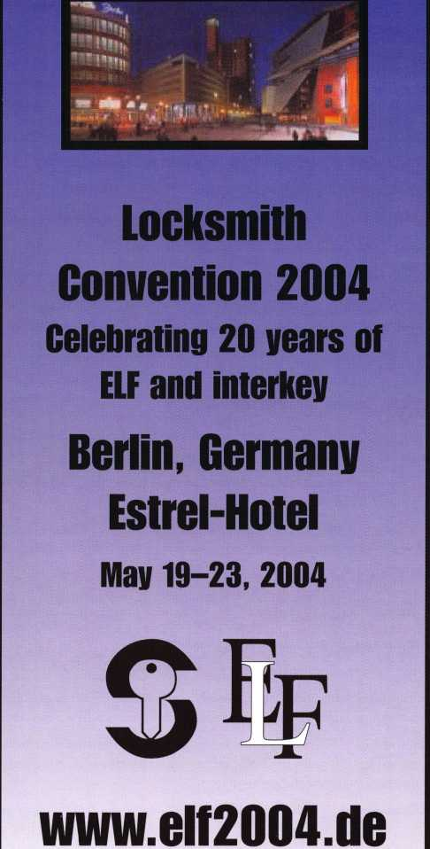

NEW ACCESS CONTROL CABLE

Cable Systems, LLC, has introduced a new  
line of access control cables featuring four  
individually shielded cable groups under a  
single jacket. Created to save locksmiths time  
and money, the cable's conductor groupings  
are separated using specially-colored overall  
foil wraps for quick, accurate identification. A  
stranded drain wire and either a green non-  
plenum or a yellow PVC plenum jacket shields  
the components. These access control cables  
are specifically designed for wiring door

strikes, card readers, door contacts or requests for exit applications in pub-  
lic buildings such as hospitals and government offices, as well as in com-  
mercial and retail outlets where security and safety are important.

They are UL-Listed, dual rated and 100 percent guaranteed.

For more information, call Genesis Cables Systems at 1-800-222-0060.

On the Internet, visit Genesis at [www.genesiscable.com](http://www.genesiscable.com).

In Memory

David L. Griffin (ALOA #19228) of Doctor Key in Olney, MD, recently died while visiting a friend in Pennsylvania. David was a member of MLA and LADC. On behalf of everyone at ALOA, we wish to extend our sympa­thies to the Griffin family.

ALOA Code of Ethics

All members of the ALOA by acceptance and continuance therein, shall be deemed to have subscribed to the following Code of Ethics:

That the dignity of our chosen profession may be perpetuated, it is the duty of all members of the ALOA.

* To practice their profession in the spirit of fairness to their clients, with fidelity to security in conformance with appropriateness, and with high ideals of personal honor;
* To properly and impartially analyze security problems, and to advance the best possible solution for the protection of their clients;
* To conduct themselves in a dignified manner;
* To abide by applicable licensing and business regulations;
* To abstain from using improper or questionable methods of soliciting patronage, and to decline to accept such incompatible patronage;
* To refrain from associating themselves with or allowing the use of their names by any enterprise of questionable character, or in any manner countenancing misrepresentation;
* To cooperate in advancing the best interest of the locksmithing industry by interchange of general information and experience with fellow lock­smiths;
* To encourage and promote loyalty to the profession, always ready to apply their special knowledge, skill and training for the use and better­ment of our industry.

Letters to the Editor Great Auto History Article

A great article about automobile keys in the January 2004 issue.

Especially about the Model Ts. Mr. Perkins did a fine job. I do have one interesting addition. The Ford garages of the era had a set of Master keys (I have a set) so you could drop your vehicle off for service and take your keys with you. There are four keys riveted together. Number one key would start ignition units 51 through 56, number two would start ignition units 57 through 62, number three would start ignition units 63 through 68 and the fourth key would operate vehicles 69 through 74. These keys were made by Ford Motor Company, and issued to the Ford dealers. The blades are flat, .035 steel, one inch in length by .365 inches in height. I keep mine on the clipboard just in case a guy at a car show loses his keys! Ha! No, I wouldn't part with them.

Respectfully, Alex Cartwright, Hoopeston, IL

Thanks for the Free Advertising

Gentlemen:

Thank you for the free classified advertising service available to all mem­bers! It is a big help.

Sincerely, Bruce D. Stevenson, Buckingham, PA

Let Us Know!

If you have an opinion to offer on ALOA, the state of the industry, or life in general, we want to know about it! Submissions to the "Mailbox" section of Keynotes are printed on a space-available basis. Write to: "Letters to the Editor"; ALOA; 3003 Live Oak Street; Dallas, TX, 75240; FAX 214/827-1810; e-mail: [editor@aloa.org](mailto:editor@aloa.org).

Need Help?

At ALOA, we want to make sure you are getting as much bang for your membership dues buck as we are able to give you. If you have had prob­lems getting membership services, or have a question regarding member services, please contact Bill Gibson, executive director, at 800/532-2562, or e-mail: [charlie@aloa.org](mailto:charlie@aloa.org).

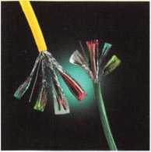

Videx Announces CyberLock® Intelligence in Padlocks

Padlocks that Report Who, What, Where, and When!

Videx recently released CyberLock Electronic Padlocks, designed to bring key control and an audit trail of every opening to padlocks. A standard padlock can be quickly converted into a full-functioning access control system by replacing its mechanical cylinder with a CyberLock electronic cylinder. Padlocks retrofitted with these intelligent cylinders aim to provide smart security wherever controlled access and an audit trail are needed. These padlocks report Who, What, Where, and When.

This electronic padlock system consists of the pick-proof CyberLock cylinder in a padlock, a CyberKey® that cannot be duplicated, and CyberAudit® access control software. Access privileges and battery power are located in the key. A key can be programmed to restrict each authorized user’s access to specific padlocks on pre-selected days and times.

Each time the CyberKey opens a padlock, a record of the user ID, date, and time is stored in both the lock and the key. A key can be set to automatically expire within minutes, hours, days, months, even shift-by-shift, depending on the specific task that has been assigned to the user.

CyberLock padlocks are ideal for securing equipment, containers and gated areas — anywhere an audit trail would be beneficial. New padlocks with the electronic cylinders already pre-installed are also available. In addition to padlocks, CyberLock cylinders can be installed in safes, server cabinets and doors, throughout entire facilities.

For more information about CyberLock padlocks, please contact Videx by phone at 541.758.0521, by fax at 541.752.5285, by email at [sales@videx.com](mailto:sales@videx.com), or visit the web site at [www.videx.com](http://www.videx.com).

**Key Name**

Andy Dummore Juanita Banks Evelyn Idler John M chads Sussman

haney

1 **Lock Name jc Date/Time jStatus [ Source** *

South Equipment Yard 11/12/01 1:38 58 PM No Permissions Key

South Equtpwftf Yard 11/12/01 1215:44 RM Authorized to Open Key

**{West Equipmen**t Yard South Equipment Yard **Cel Tower 3**

11/12/01 1021:04AM  
11/12/01 8 4538 AM  
**111/12/01*21:08 AM**

Authorized to Open Key

Authorized to Open Key

Out of SchecMe Key

West Equipment Yard Cel Tower 7

11/12/01 **81521** AM

11/12/01 7:15:22

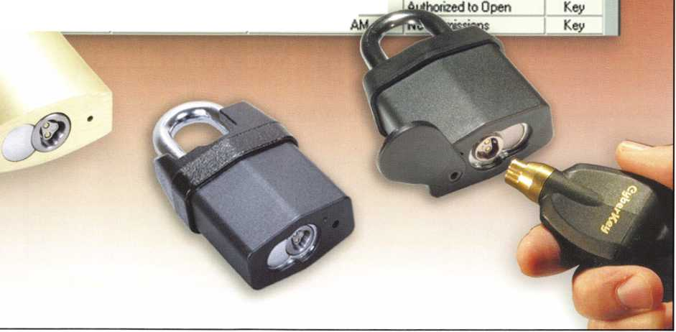

Wonderful World of EAC

By Adam Black, CRL

II

**2**

Keynotes • March 2004

I can still remember the first time I saw it. The fear in my eyes, the sweat on my brow ... I was tormented. I was working on a lock, and my worst nightmare had come to my conscious realm: a “wire” was attached to the lock!

Locksmiths have no problem ripping apart a mortise case, installing concealed panic hardware from scratch and fixing all the honey-dos on the weekend, (which include working with all kinds of electrical appli­ances), but when we see that a lock is electrified, we go into fear mode. In locksmithing, the “fear factor” is not eating cockroaches and dangling from a helicopter over a bed of anacondas; it is electronic locks, circuit boards and relays.

Well, never fear; hopefully we can work together to take away some of that fear and turn it into big bucks. One of the most lucrative parts of locksmithing is Electronic Access Control (EAC). We are going to start with simple EAC systems and finish up with some more complicated systems (such as used in large buildings, nationwide businesses and world-wide cor­porations). Before the fear starts growing again, well start at the beginning.

Access control is a catch phrase that our industry uses to explain what skills we offer that are related to elec­tronics. Let’s have a little fun and define what “access control” is, and how it is perceived by our patrons. Access control means ... are you ready? ... controlling access. Ta-da! We’re all Rhodes’ Scholars. Actually, access control is any mechanism by which a system grants or revokes the right to access some data, or perform some action. (©2004 M-Tech Information Technology, Inc.) For such a simple definition, it sure causes a lot of confusion. Let’s use an analogy to explain this. Before dinner, my mom’s slapping of my hand at the cookie jar is access control. That is how our customers see access control; however, that is not how we understand it, and after we try to explain it (our way), customers’ heads explode. We probably

would be better off explaining that we install “those card swipe thingies that let you in a door.” (Unfortunately, that doesn’t fit on the side of a van.)

OK, my lame jokes have run out, so let’s jump in and begin gaining confidence in a portion of our industry that will become a major part of what we do. We are first going to define the three main levels of EAC and then we take it from there and run with it.

Electronic Access Control (EAC) comes in three main levels:

* Stand-alone units: Key pads, card readers, biomet- rics and battery-operated devices - these units are controlled and programmed from the device itself and are not connected to a computer or other doors.
* Simple computer-managed systems - These sys­tems use the same style of products (i.e. keypads, card readers, etc.), but are managed by a PC-based system using software to add users, set up time zones, access levels and pull audit reports of users.
* Multi/Complex/Enterprise systems — These take our system to the next level where we integrate with alarm systems, CCTV, building automation and multiple sites.

We are going to talk about all of these and much more over the course of our discussion. Let’s get started.

STAND-ALONE ACCESS CONTROL

Stand-alone access control basically offers a little more convenience over a mechanical lock and key It allows us to enter a door, gate or secured area with nothing other than our knowledge (code), card or bio­metrics (fingerprint, handprint). Codes are great because they allow access with nothing more than punching a number. The downfall with a code is that someone could discover the code by looking as we push the buttons, or by us giving it out. This brings us



Keynotes • March 2004

to cards or key-fobs. Cards are the next level of secu­rity We tend to hang on to our ID card or key-fob, whereas we might give out our pin number (especially with a financial deposit). And finally, with biometrics our unique bodies are virtually impossible to duplicate and give the highest level of security All of these (pins, cards and biometrics) are called “credentials.” We will be using the term “credential” in the future. Finally, with stand-alone systems, you get convenience with no accountability, no way of finding out who came in, or when.

SIMPLE COMPUTER-MANAGED SYSTEMS

This leads us to the next level: computer managed systems. I realize that many people familiar with the stand-alone systems know they offer audit capabili­ties. I didn’t forget; it’s just that they require a good oF computer to retrieve the audits. Computer-man- aged systems (CMS) allow data, such as users, time zones, etc., to travel back and forth from the system to the computer. This is not magic, no Doug Henning or David Copperfield required. We just need a cable, modem, wireless device or a local or wide-area net­work (LAN WAN). With CMS, we can attach times, days and locations to either a person or a door. We can allow someone to only gain access to an area at certain times, while someone else may go to other areas at completely different times. We can control when doors lock or unlock. We can “re-key” a whole building with the click of a mouse. One of the great­est features with CMS is the ability to see who went where, and when. Management is able to track when employees come or go, and can help narrow down who is involved in any situation, such as theft or acci­dent. The only real limitation with smaller CMS’ is the size of the memory on the units themselves. The memory holds the users and event buffer, which, when full, can cause problems as well as lost data.

MULTI / COMPLEX /

ENTERPRISE SYSTEMS

Finally, are our larger and more complex systems. These are the ones that make you want to pull your hair out. (I am the poster child for this.) These sys­tems are really only an extension of the smaller sys­tems with the ability to integrate with CCTV, alarm panels, building automation and networking with many other buildings. One of my favorite things to do is to unlock and lock doors 3,000 miles away with the click of a mouse. (Obviously, I have no life.) Bigger systems allow a security department to control multi­ple buildings from a central location without the man­power required with mechanical hardware. Adding cameras to these systems gives a visual verification that doors are secure, dropping manpower even fur­ther. Larger systems communicate through the cus­tomers’ network. Like many other enterprise pro­grams (network), they can be managed from several locations. This is accomplished by using a single data­base on the server. Maybe a little Greek sounding, but hey, we need a little Greek to prepare for the summer games. Large systems do require careful preparation and very detailed organization. Even with the extra work, the basics are still the same, and the satisfac­tion of seeing a larger system come on-line and work is akin to opening a TL-30 that’s been burglarized. Quite nice! EAC still has one element that it cannot perform on its own: maintenance and physical inspec­tion. Much like larger master key systems, EAC needs us to keep everything running smoothly. That is why it is crucial that we understand the basics of EAC, lock function, wiring, power, relays, resisters, diodes, MOVs, and transorbs. With this basic knowledge, we can service and satisfy our customer base as well as future prospects. As locksmiths we have a distinct advantage in EAC. Our competitors are not the big hardware chains as in traditional locksmithing, but alarm and building automation companies. We have such an advantage over these competitors:



Keynotes • March 2004

* They can run wire; so can we.
* They can hang card readers and access panels; so can we.
* They can hook up to a computer and set up the system; so can we.
* They can install locking hardware, rekey locks, hang door closers and finish the job...Oops, I think not! WE CAN!

Locksmiths can offer a full package of security that no others can. From file cabinets to lock-outs, to safe openings, to Life Safety applications, to master-keying and now Electronic Access Control.

We are going to start with a very simple single door, pin number access system and grow from there. I hope by the end, we can all have a better understand­ing of Electronic Access Control and how we can be an integral part of its future.

About the Author: Adam Black has been in the locksmithing profession since 1981 starting with Vincent Safe and Lock in Bakersfield California. He has been with Cothron's Safe and Lock since 1997. He has instructed ACE classes in Access Control, Safe Lock Servicing, Impressioning and Picking and is a cur­rently an instructor for Cothron's School of Professional Locksmithing in Austin, Texas.

**THE HINGE DOCTOR**

**by GKL Products**

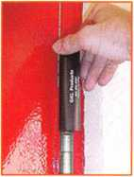

**HA1 For  
Standard**

**Commercial**

**4-1/2" x 4-1/2”**

**Butt Hinges**

**HA2**

***"The HULK***

**For Residential Hinges**

**COMING IN  
SEPTEMBER**

**HA3**

**For Ball-**

**Bearing &**

**Commercial Hinges**

US Patent **#6450003**

**[www.hingedoctor.com](http://www.hingedoctor.com)**

**800-924-5397**

**10,000**

Satisfied

Customers

**The Hinge Doctor is a great way to repair those sagging metal**

**doors. Slip the tool over the hinge and open the door an inch**

**or two past the point where the tool binds against the  
hinge, remove the tool and check the door,**

**which should now be working properly.**

**If you're a locksmith these tools  
will turn a profit the 1st time you  
use them!  
Uses - schools, hospitals,**

**commercial buildings, storefronts**

**with butt hinges, office doors, new**

**construction, door alignment, sagging  
doors, jail cells, anywhere there are  
commercial grade hinges.**

**HA4**

**For Prison**

**& Institutional**

**Hinges &**

**Spring Hinges**

Over

Keynotes • March 2004

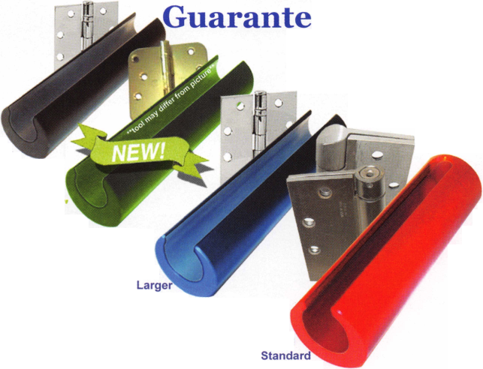

Don’t Drop The Lock!

By Greg Perry CML, CPS

**16**

Keynotes • March 2004

This article came about because of a mistake on my  
part. As I was taking the last screw out holding the  
Von Duprin 99 exit device through door to the OSI  
OMNILOCK OP2000, I received a call. I took my  
hand off the OMNILOCK to answer the call. Turning  
back to the job at hand, I finished removing the last  
screw. Most of you can guess what happened next.

The OMNILOCK fell off the door and the high  
impact plastic proximity reader received a high  
impact test as it hit the concrete. It did not sur-

vive! The buttons scattered around the impact

site. I looked at my customer and back at  
the now broken lock on the ground. He  
was stunned, and the only thing he

could say was, “It’s Monday.”

Looking at the pieces revealed that the lock could be  
reassembled. The only part broken was the reader on  
the front of the lock. But it also holds the stainless  
steel plate in place that holds the buttons in position.  
My customer has a spare cylindrical lock for training,  
and has a spare for his facility. This was the panic ver-  
sion. I disassembled the lock to disconnect the reader  
while he went to retrieve the other lock and download

the program to his pocket PC handheld computer.  
Once he got back, I installed the new reader onto the  
panic lock and reinstalled it on the door, making sure  
not to drop it this time. He reprogrammed the lock  
and I took the now broken reader with the cylindrical  
lock back to the shop to send in for repair. But first,  
let’s look inside at the boards and get an idea how this  
lock works.

Starting with photo 1, we see the OMNILOCK  
OP2000 lock as it should look (with the addition of a  
little tape to hold the reader in place). This lock is  
built on a Schlage D80 Rhodes chassis. The panic  
version is built with a back plate to mate with a Von  
Duprin 99. The back plate has through-bolt type  
studs that match the hole pattern of the 99. Turning  
the lock over (photo 2) reveals the gasket and

battery cover. If this were the panic version, the

back plate would need  
to be removed

to reach  
this  
point.  
Peeling

back the gasket  
from the top,  
removing the  
screw in the  
center of the

&&& upper plate

and remov-

The OMNILOCK fell off the door

and the high impact plastic proximity reader

received a high impact test as it

hit the concrete.

Keynotes • March 2004

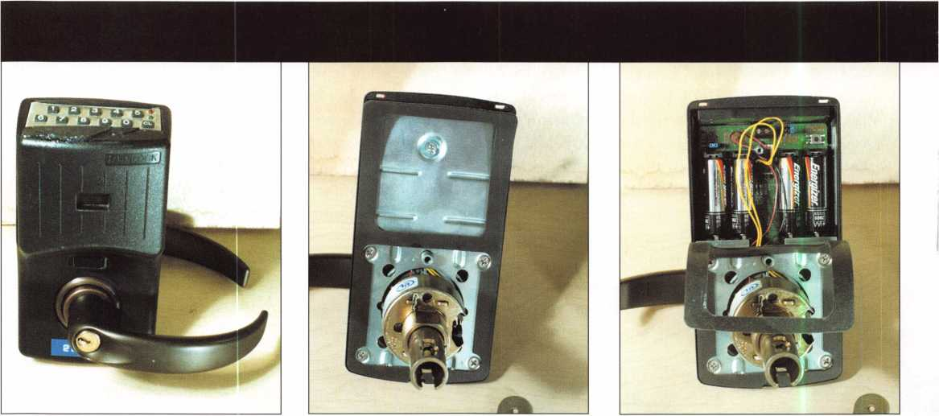

ing the plate reveals the batteries as seen in photo 3. Normally this is as much disassembly as might be required. If the hand of the lock needs to be changed, the lower plate is removed. Next, seen in photo 4, the two wires running from the lock chassis are discon­nected from the circuit board. The red and black wire pair is from the lock solenoid; the yellow pair is from the optional key bypass detection switvu

The lock can now be rotated to the other hand, and the wires reinstalled (using care with the red and black wire pair to install the plug in the orientation seen on the circuit board). Install the batteries and reassemble the lock back plates before installing the lock on a door. Before leaving this picture, we need to look at the top center of the circuit board. Here we find a two-screw terminal connector. This is to allow for a remote release switch, as might be found at a receptionist’s desk.

If this lock had not fallen off the door, a few program­ming instructions might be all that is left. But this lock did fall and break, so let’s look a little deeper into the lock case and see what some of the compo­nents look like. After disconnecting the wires, the lock chassis can be removed from the outside hous­ing. Removing the coupling nut/stud just above the wire connectors and the two lower screws allows us to remove the main circuit board (photo 5). The board still in the lock is the interface board from the prox

1

reader on the outside. The ribbon cable running from the lock housing to the main circuit board is from the keypad. Also seen in the photo at the top of the now upside-down circuit board are the two LEDs used by the lock to send and receive information from a pock­et PC. The window for these LEDs is seen between the interface board and the hole for the lock set.

The cable running to the prox reader can also be seen plugged in on the upper right side of the inter­face board. Photo 6 is of the reader, the loose buttons and the button cover plate. Photo 7 shows how the buttons just sit on the keypad membrane requiring the stainless steel button retaining plate to keep them in place.

Why use an OMNI LOCK? First is ease of installa­tion. Unless you need to have a remote release, there is no wiring involved. The lock is part of a self-con­tained, full-featured access control system. Multiple doors and/or locations can all be controlled with the same software. In some cases, wiring is not feasible, or you don’t prefer (or don’t have experience) running wire. Multiple locations miles apart require the use of modems or Internet connections which, for most of us, is outside our skill level. OMNILOCKs are a great fit for this application. Another great fit for the OMNILOCK is a fire-rated opening, since the door or frame cannot be altered unless you are a UL door shop. The OMNILOCK is available in several config-

**8**

Keynotes • March 2004

urations. First is the standard cylindrical door prep built on either the Schlage or Arrow Grade i chassis.

It is available mated to either a Falcon or Schlage mortise lock. They also produce a switch lock version for use with a magnetic lock or electric strike. The panic version has already been mentioned. Select existing Schlage D series locks can be retrofitted with the OMNILOCK Quick Adapter. And finally OSI produces an OMioo, OM200, and OM500 keypad only users who need fewer features.

What is the downside to using OMNILOCKs? First and probably the biggest drawback is the need to actually be at the lock to perform changes to the pro­gram or to download the event history. Unlike a hard­wired or modem-based system that can be accessed from a single location, the OMNILOCK requires the use of a pocket PC to transfer data between the lock and the host computer. Another downside is the need to remove the lock from the door to change the bat­teries. Batteries should be changed one a time. Removing all the batteries at the same time will cause a loss of programming. Most users are not skilled enough to properly remove the lock and reinstall it. Some might even drop the lock off the door if it is mated to a panic.

Programming as mentioned earlier is accomplished with a PC and pocket PC. The OFM or OMNILOCK Facility Manager software is installed on the PC after installing your pocket PC software. The software is similar to the software used by most other access control manufacturers. The programming

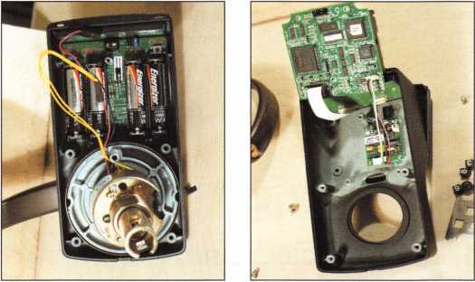

manual is over 50 pages long, so I won’t cover all the programming. I will provide a brief overview. Several parameters are selected starting with the facility, loca­tion and lock. The locks can be set in any of 8 modes, from unlocked, to code-and-card, to complete shut­down, allowing access only to the programmer. Time schedules and holidays are set into the lock, if desired. After all of the user and lock information is entered at the PC, the information is loaded onto the pocket PC for transfer into the lock. A trip to the lock is now required to download the program to the lock.

The OMNILOCK is a great choice for many applica­tions. It is probably the most easily installed full access control system out there today. Battery life is four to five years, and it will continue to operate for over 1000 uses, giving plenty of time to change the batteries before total shutdown (provided someone notices the low battery alert). The need to use a pocket PC to transfer information can be a real problem, although in general, that is the user’s responsibility. All things considered, OSI OMNILOCK offers a lot of versatility in a small package. And that’s the name of the game in today’s electronic access control market.

About the Author: Greg Perry, CML, CPS, has been in the locksmith industry for  
20 years. He's spent half of that time as a field technician for Security  
Engineering in Ridgecrest, CA. Greg is also a past president of the Desert

Counties Chapter of the California  
Locksmiths Association. He has also  
won the 2002 and 2003 Keynotes  
Author of the Year Award. You can e-  
mail him at [glmperry@iwvisp.com](mailto:glmperry@iwvisp.com).

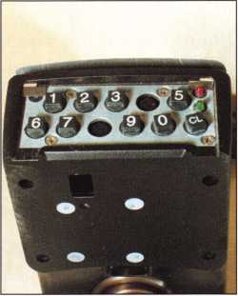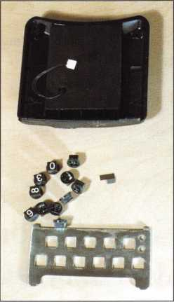

Keynotes • March 2004

“That’s three rings! Somebody get the phone please!”

I glanced at the clock: 8:02 a.m.!

“Somebody turn the OPEN sign around please!” “Right away!” Dave replied.

“Where did all the calls go?” I looked at the empty dispatch board.

“Right here!” Chad thumbed through them. “There’s a lot of em’!”

“What’s first?”

The phone rang again.

“Let me get that!” he replied.

Monday! I grabbed my almost empty cup of coffee and used the moment to walk the facility. Lights. Bathroom.

“When’s the bathroom getting cleaned?” I bellowed, in my usual broadcast fashion.

A voice echoed from the stock room, “Right after I put this stock away.” It was Mac. His real name’s Dave, but since we already had a Dave, he suggested we call him Mac. Then I heard Chad hang up the phone.

“Who was that?” I asked.

Lowering his head a bit, he said, “That was Jim.”

“Great!” I raised my eyes to the top of their sockets. “Let me guess: He’s sick, right?” “Kinda,” Chad said. “He twisted his ankle yesterday watching NASCAR and today it’s worse. He’s going to the doctor this morning.”

“Twisted his ankle watching NASCAR — in his living room? Oh that’s just wonderful!” I thought to myself, “We’re already short handed. What’s next?”

Phone rings again. Thinking quietly to myself, “I’ve got to get a handle,” I picked up the phone. “Tri-City Security this is Ray may I help you?”

“Ray, this is Fred, Big Mountain.”

Big Mountain is one of the local Harley Davidson dealerships in our service area. Fred’s been working there in Parts since the place was built, which is about how long I’ve been trying to make him a steady cus­tomer.

“Hey Fred, how’s it going?”

Fred cut to the chase. “Remember when you stopped by and said you can service our (Harley) locks?”

“Yep. But you said you already had someone doing that.”

“I know, I know. I guess I was wrong, dead wrong! I’m really upset with him because now I have a really big problem!”

“What’s up?” I asked.

**aYour** competitor” he said (as if I only have one), “has a switch of ours for two days now and it’s not done, and he can’t say when it’s gonna’ get done.”

“Oh.”

“Somebody came in here a few weeks ago and bought a brand new $30,000 bike, but the ignition lock failed. We replaced it, but it uses a different key and that’s not good enough for him, and he’s gonna’ scream bloody murder if his bike isn’t ready this after­noon, cause he’s supposed to leave for Sturgis tonight.”

“Oh!”

Then, after a long sigh and with the humility of a beg­gar he asked, “Can you help me?”

I had no idea which switch Fred was talking about, but after all the time I spent hounding him for busi­ness, this was no time for questions or excuses; it was time for action. It was time to pluck him immediately from the jaws of impending embarrassment. With confidence and a sense of urgency, I said, “Well, what are you waiting for? Go get that bad boy and bring it to me now!” and hung up the phone. With that job

Cycle Chronicles - Part 4:

Harley Davidson and The Miracle Man

By Ray D’Adamo, CML

**20**

Keynotes • March 2004



locked down, it was time to get other jobs moving. “Dave!” I screamed, “You and Mac get on those calls.

I have a rush job coming in,” and I prepared for Fred’s arrival.

When Fred arrived he brought the lock, its operating key and the bike’s operating key (photo i). The Harley tubular tank mount ignition switch is a handsome thing. The entire upper part of it is plated in chrome. In the past, I had fit keys to identical units without the need for disassembly, but re-keying was something with which I had no experience. After an initial inspection of the unit, I realized that in the past two days, absolutely nothing had been done to it. I thought to myself, ‘At least I won’t have to repair it first.” As I proceeded with my inspection, I couldn’t help but wonder why my competitor was so chal­lenged by this re-key? I opened the dust cover and then I saw it (photo 2). One cannot see this in the photo, but the dust cover was blocking access to the cylinder retainer pin (Photo 3). Additionally, the dust cover hinge pin was installed into a blind chase (only one end). With all we had going on that day, time was tight, but regardless of the work load, I felt this job was doable, as long as I didn’t get distracted with other work. Saying nothing, I continued examining the lock, making sure I didn’t miss anything obvious.

All the while, Fred was leaning over the front counter facing me. With a stark look on his face, he whis­pered, “Impossible, huh?” Feeling confident I was capable of doing this, I took into consideration all we already had on our plate that day and answered

“Impossible things we do right away. This is gonna take a miracle.” Just as his jaw dropped completely to the floor in despair, I followed up that statement with, “Since miracles take a little longer, we won’t have it done until lunch time.” Fred raised his head, closed his eyes and breathed a big sigh of relief. “If you pull this off for me,” he said, “you’ll get all my business from now on.” and he walked out the door. As I heard his departing steps I thought, “I’ve been waiting for a long time to hear him say that.” Then it reality hit me and I felt the full impact of the situa­tion. I thought, “If I fail, I’ll be the laughing stock of the entire Harley dealership and I’ll never see or hear from Fred again.” Cautiously, I began servicing the lock, knowing full well this was do or die!

The way I saw it, I had two options for removing the dust cover. The first was to drill a hole into the hinge pin from the open end of the chase and try to extract it. The second was to drill a small hole at the other end of the dust cover directly over the blind end of the hinge pin, and drive out the hinge pin. I chose the second option, understanding that when finished, the newly opened chase end must look just as good (if not better) than the stock open end. This would require precise measurements before drilling. Then, the unex­pected happened! Something came up that I could not avoid, and I was forced to discontinue servicing the lock. Frustrated, I searched for a solution. Just then, one of my more competent apprentices, who realized that the situation had taken a turn for the worse, leaned over my shoulder and asked “What’s up?” I looked at him square in the eyes, thought to

Keynotes • March 2004

Photo 1

Photo 2

Photo 3

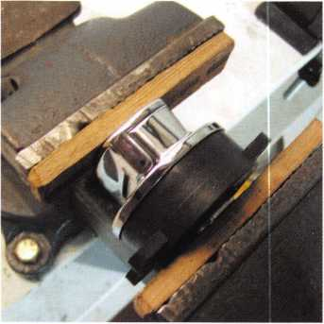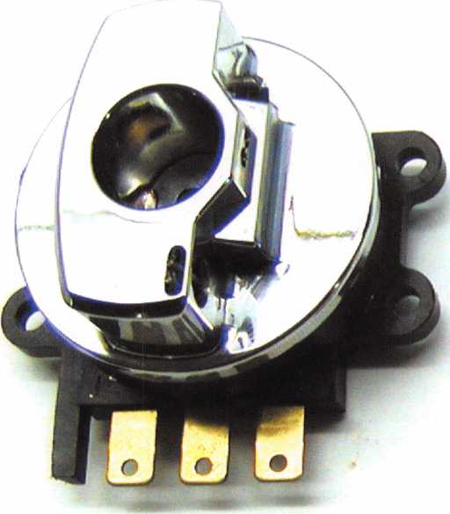

ing across the room as they exited the chase. After removing the dust cover from the assembly and then combing the area for a minute or two to locate and retrieve the brass pin retainer and the hinge pin, the rest of the process was academic.

The cylinder retainer pin (photos 6) was next to be

myself, “He can do this,” and after going over my thoughts with him, I turned over the job to him, and this is what he did in my absence.

He decided to stick with the second option. After  
carefully estimating and marking the location of the  
hidden hinge pin end (photo 4) and choosing a small

drill, he opened the closed end of the  
hinge pin chase (photo 5). Choosing a  
small punch and anticipating some resist-  
ance (thinking the hinge pin had a press  
fit); he struck it with what he felt was  
appropriate force. Then, once again, the  
unexpected happened. Unknown to both  
of us, what we thought to be the end of a  
press fit brass hinge pin at the open end  
of the chase was in reality a short brass  
retainer plug, which secured the relatively  
loose steel hinge pin in place. Needless to  
say, when the hammer hit the punch, the  
hinge pin and retainer plug went careen-

&

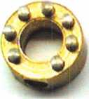

Photo 4

Keynotes • March 2004

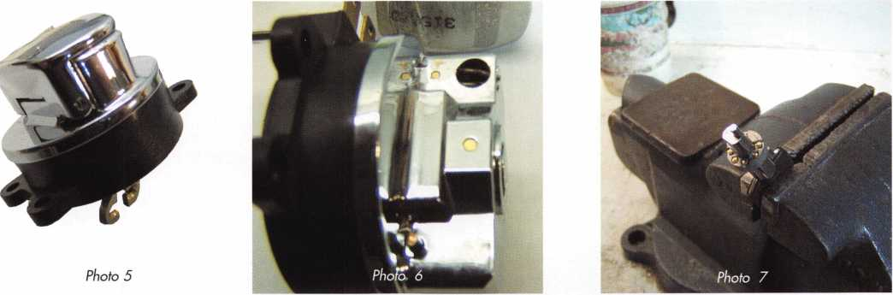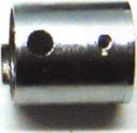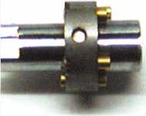

Photo 8

removed. Drilling a small hole next to the cylinder retainer pin, he used this space  
to pry up and remove the pin with an awl. After lifting the cylinder from the hous-  
ing, re-keying it first required removing the serrated retainer pin (similar to Chicago  
ACE’s retainer pin), which keeps the cylinder together. This pin has a hole drilled  
through the center, so a sheet metal screw and a slap hammer did the job. Photo 7  
displays the bottom of the nose plate, which houses the bottom pins. Note the anti-  
tamper notches. When pinning, always use a pin that will shear with the thickest  
part of the nose plate. As with most tubular lock pinning, also make sure the round-

ed end of the bottom pin faces the top pin; the flat end should face the key.

Though Harley top pins (photo 8) are cupped to contain the spring,  
the short master pins, which are contained in the Chicago ACE

pin kit (Harley also utilizes the same specs as Chicago ACE)

will substitute when necessary. An exploded view of the

entire assembly can be seen in photo 9. Soon the cylin-

der was re-keyed, re-installed. And soon after that,

the dust cover, hinge pin and hinge pin retainer  
cap were re-installed, and the lock looked

and worked great!

Things don’t always go the way we expect.  
Somehow, though, with enough experience, intu-  
ition, perseverance and a desire to succeed,  
they sometimes turn out better

than expected and the results  
astonish us. That’s probably  
why we call them miracles.

Now let’s see if the other mira-  
cle happens. You know. When  
Fred calls me for more work!

See you next time for another  
exciting installment of Cycle  
Chronicles.

Photo 9

Raymond D'Adamo, CML is originally from Hoboken, NJ. In 1973 he graduated Rutgers University and in 1977 he began locksmithing in Boulder Colorado. In 1981 he began writing automotive locksmithing technical articles for locksmith publications, and began instructing automotive lock- smithing courses at trade association meetings and conventions. In 1983 he and his wife Tina D'Adamo moved to Fort Collins, CO and opened Fort Security Center. Since then their business, TRI-CITY Security, has grown to two additional facilities in Greeley and Loveland, CO. Ray is an active member of ALOA since 1978 and continues to contribute to the education of locksmiths all over the world. ■■

Keynotes • March 2004

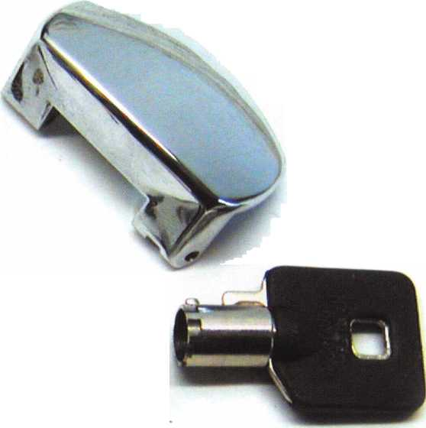

Changing Safe Combinations

By Jim Hancock, CRL

Keynotes • March 2004

Before you begin changing combinations, you must first understand the rotations of the dial and what you accomplish when turning the dial. This will not only enable you to change the combination, but also allow you to explain the dialing sequence to the customer, which will save a return trip in the event the customer doesn’t understand the dialing procedure.

The majority of all safe locks will utilize a left-right- left dialing sequence. It will be a surprise to you how many people will falter on their left versus their right when it comes to dialing a safe combination. Dialing a safe combination to the left means rotating the dial in a counterclockwise rotation; another way to view it is turning left will increase the numbers on the dial while turning right (or clockwise) will decrease the numbers on the dial. Also, the majority of these same safes will work on a 4-3-2 rotational pattern. This means you will rotate the dial 4 times left, then 3 times right, then 2 times left to dial your combination numbers. The last turn in this sequence would be to the right to open the safe. As you see combinations written on paper, you generally will see a number asso­ciated with this rotation; however, you need to under­stand and make your customer understand that this number is simply a reference point. If the combina­tion is dialed correctly, in 90 percent of all safes, the dial will come to a complete stop by itself and will not turn any further. The usefulness of the last number is to give you, the safe technician, a reference as to where the drop-in point is in the event you have a lock-out situation. It also acts as a good benchmark for your customer in the event of a lockout, as it gives them a point of reference for opening.

Let’s think about what is happening inside the lock as we rotate the dial to move the wheels. Start by turning the dial to the left, counterclockwise, slowly. At first, there should be little resistance, since all you are mov­ing is the drive cam. As the dial approaches a full 360 degree turn, you should feel the drive pin on the drive cam contact the fly on the third wheel. The third wheel is now moving as you turn. As you rotate the dial another revolution, you should feel the drive pin

on the third wheel contact the fly on the second wheel. Now both the third and second wheel are turn­ing with the dial. As you approach another 360 degrees, you should feel the drive pin of the second wheel contact the fly of the first wheel, which now will rotate as you turn the dial. It took four complete revolutions to make all the wheels rotate. This is why all three wheel combinations start with, “Turn the dial four times left,” or right, depending upon the type of lock. With each change of direction in the rotational pattern, by turning one revolution less, you leave the previous wheel “parked” in the position designated by the number on the dial where you stopped. For exam­ple, let’s assume your combination is four times left to 25, three times right to 50, two times left to 75, right one time to open. The procedure would be as follows:

1. Turn the dial left, counterclockwise, at least four times to make sure all the wheels are moving together. It hurts nothing to rotate the dial more than four times since all you are doing is moving them together. Stop on your first number, which is 25.
2. Now rotate your dial right or clockwise. With each successive turn of the dial, every time you pass 25, you will make another wheel move there­fore you will pass 25 twice, which will make your third and second wheel rotate and stop on your second number, 50. **You** now have parked your first and second wheels on their respective num­bers.
3. Rotating left, pass your second number once, then stop on your third number. Again by rotating the dial one complete revolution you have begun to move the third wheel. Once you have stopped on your third number, all of the gates in the wheels should now be lined up under the fence and the safe is ready to open with one more step.
4. **You** now should rotate the dial right until it no longer turns. The safe is now open if everything was done correctly.



Keynotes • March 2004

The same sequence of rotations you use to open a safe will be the sequence you will use to change the combination, with two notable exceptions. First, you will dial the existing combination to the change indi­cator on the dial ring. The dial ring should have two marks on it. One mark, the opening index, is the mark located at the 12 o’clock position and generally referred to as the crow’s foot, because of the unique shape of the mark. This is the mark you will use to dial the combination for opening the safe. However, there are several brands of dial ring that use only a single line mark, or even a dot, for this purpose. The mark you will use for changing the combination is the mark slightly off center of the dial ring. This mark, the changing index, is generally a single line mark and is almost always 8.25 number points to the left of the opening index. I say generally because, again, there is always an exception to every rule. **You** will see some safes that have the change index to the right of the opening index and even some that have no index. We will first deal with a standard change index.

The second exception is that you will never dial the fourth number in the combination to the index. As you learned earlier, this number will never change, as it is pre-determined by the drive cam gate and can’t be changed without changing the position of the drive cam. So with this in mind, let’s change the combo.

COMBO CHANGING

Rotating the dial left at least four revolutions, stop your first number on the change index. Rotating right, pass your second number twice and stop it the third time on the change index. Now, rotating the dial left, pass your third number once stopping it the second time on the change mark. At this point there is no need to rotate the dial any further as all the wheel gates should be lined up at the change position. No you should be able to insert your combination change key into the slot in the back of the lock box. Make certain it seats properly because if it does not, the results of a failed attempted change could be cata­strophic. Once the key is seated, turn the key, general­

ly a quarter turn, which will unlock the inner hub from the outer wheel, allowing the hub and wheel to change relationships with each other, thereby chang­ing the combination. Once the wheels are unlocked, dial the desired new combination to the change index, turn the key back to the neutral position and remove it. If all of these steps were completed correctly, the combination is now changed. Test the new combo several times to verify that it works correctly. DO THIS WITH THE DOOR OPEN. Also, allow the customer to try it multiple times at this point. If indeed it works on the new combination, you are ready to write your invoice and go to your next job.

OUT OF THE ORDINARY

Now let’s discuss a couple of the out-of-the-norm things you might find. First might be a change index on the opposite side of the opening index. This pres­ents no problem and should change exactly like the regular index. Second might be no change index at all. This will indicate one of three possibilities. One would be the wrong dial ring was put on the safe pos­sibly during a previous repair. This is not a real prob­lem; simply add eight numbers to your combination, which should line up your change key hubs with the access hole in the box cover. Another would be what is called a direct change combination. This is a combi­nation that is both opened and changed at the same index. This type of combination lock requires a spe­cial change key that, when turned, actually holds the lever out of the way, disallowing it to drop into the gates while you change the combination. The third possibility is a hand change combination.

A hand change combination requires some disassem­bly, but is relatively simple to accomplish. When you remove the two screws that hold the back cover in place, the cover will come off with the wheels attached. The drive cam remains in the lock body. After removing the spiralox washer or retainer, each wheel will lift off the hub post. As you look at these wheels, you will see a mark on the wheel where the inner hub and outer wheel connect. This mark points



Keynotes • March 2004

to the number associated with the combination. By firmly pressing the hub, it will separate from the outer wheel. By realigning the mark to a new number, you have changed the combination. Keep in mind that the wheel closest to the hub is the third number in your combination. Do not get confused by the fact that the drive cam is in a reverse location from the normal lock, as this will cause you to pull your hair out trying to figure out why the combo doesn’t work when what you are doing is moving the wheels in an opposite manner from what is required.

Another thing to watch out for is the four wheel com­binations and the reverse rotation combinations. Neither of these are a real problem in that they will change just like the others, by either reversing your rotation or adding an extra rotation to the front end of your dialing procedure to accommodate the added wheel. Again, visualize what is happening inside the lock as you turn the dial and there should be no prob­lems with any small quirk thrown your way.

THE GOOD, THE BAD AND THE UGLY

Now, are there good and bad numbers to set a combi­nation to? YES!! Never set combos on easy-to-obtain numbers, such as birthdays, phone numbers, address­es, etc. If they are easy to find, they can be found by anyone. Never use all os or 5s such as (20-30-40 or 25- 50-75). These are stock “easy” numbers and anyone familiar with safes will try these. Many of these com­binations were, at one time, factory combinations. In other words, safes were shipped from the factory set on these combinations and again, anyone knowing safes knows this. Also, we must follow the “forbidden” zone rules. These rules relate directly to the move­ment of the flies and drive pins based on the thick­ness of each. These rules are:

1. The only number in the entire combination that can be anything on the dial is the first number. It can be any number from 0-99.

IN-STOCK...MORE SAFES

***FREE Freight Program***

***(30 States)***

**AMSEC** FireKing

Gardall **hayman**

MEIUNK y/CTOR

TURfl IO

**WHOLESALE SERVICE**

800-848-9790

1. The second number can be anything provided it maintains a 10 plus or minus from the first num­ber. This must be done so as not to accidentally move wheels when we don’t want to move them, based on the thickness of the flies and pins.
2. The third number must maintain a 10 plus or minus cushion from the second number, and also cannot be set in the opening index area, which as a generalization, will be from 90 to 20.

This means that realistically instead of having 100 numbers times three wheels (100 to the third power, or 100 x 100 x 100, or a million possible combos), there are actually 100 x 80 x 50, or 400,000 combina­tion possibilities. This is still many more than you would possibly use on one safe. The key is making certain that the numbers follow all the rules so as not to create problems for your customer or yourself.

And I can not express this one emphatically enough: NEVER, EVER, EVER set a combination to just one number; if you do, you have severely damaged the security of this safe. I realize how hard some of these things will be, because every customer out there wants an easy number, and wants to pick it for you, and usually wants to use one of the “no-nos” we’ve discussed. Your job is to find a polite way to talk them out of it and convince them to use numbers that will maintain the security of the container.

2

Keynotes • March 2004

**2**

ALTERNATE OPENING METHODS

As stated earlier, the majority of safe locks will rotate left-right-left and end with a right rotation, with the dial coming to a screeching halt when the lever drops in place and the bolt fully retracts. However, there will be a few other types of openings that you need to be aware of. There is nothing worse than assuming there is a problem with a safe when, the whole time, it is simply a matter of your opening procedure being wrong.

The first opening procedure that is different would be the lock in a right hand rotation. This would generally follow the same steps as a left hand rotation, in reverse. Are there ways to determine left from right rotation? Absolutely! The first and most obvious would be the change index. As a general rule, the change index will be located on the same side of the opening index as the rotation of the lock. Index left of center, left rotation. Index right of center, right rotation. Another generalization will be the number of wheels. An odd number of wheels usually indicates a left rotation, but this is very general. A great deal of older locks will have four wheels, but will be a right rotation. The almost foolproof way to determine loca­tion would be to learn the feel of the drive cam as its gate passes under the nose of the lever. The gate has both a soft edge (one that graduates down to the bot­tom of gate) and a hard edge (one that has a severe drop to the bottom). Because the hard edge is easier to feel, we will use this as our indicator. If, as you rotate the dial to the left, you feel the hard “bump” of this edge, it will indicate a right rotation. This should make sense, since it is this hard edge that traps the lever and retracts the bolt.

Another type of common opening procedure is the type of lock used on direct drive locks. These locks do not use a lever to drop into the wheel pack for opening, but rather use an extension of the handle cam assembly to go directly into the wheels as the proper combination has is dialed. In other words, you simply dial the combination associated with the

wheels and instead of dialing for a drop-in, after dial­ing the last number of the combination, you turn the handle. This drives the assembly into the wheels, releasing the lock. Probably the most common use of this type of lock was the John Brush or Sentry safe.

Finally, you may encounter a manipulation-resistant lock. These locks are designed in such a manner so as not to allow a safeman with manipulation skills the ability to feel the gate on the drive cam, which is the heart of manipulation. These locks will require an added action to release the lever such as pushing in on the dial at the load-up area, generally zero. Or, per­haps pulling out on the dial at this same area. Or even rotating a spindle key, a “peanut” if you will, in the center of the dial to release a spring-loaded blocking plate to allow the lever to contact the drive cam in the opening area.

There are certainly other types of locks out there: indirect drive, gear drive, offset drive, etc., etc., but the servicing and operation will remain virtually unchanged.

FINAL THOUGHTS

Something to discuss that could create problems is modifying parts or “making” change keys. Any foreign part introduced into one of these locks that is not specifically designed for one of these locks could cause serious problems, including a mechanical failure resulting in a lockout. Some safe technicians will man­ufacture a combination change key when the correct key is not available; however, this requires a great amount of expertise to guarantee that no problems arise from wheels not being fully locked or unlocked. Any part introduced into a lock as a daily working part that is not designed for the lock is a bad idea. Again, these locks are made to precision specifica­tions and designed to work together in a certain man­ner. Any outside influence on the way the parts inter­act is detrimental to the ability of the lock’s contin­ued operation. This is a fancy way of saying “DON’T DO IT!” **You** may also encounter locks that have been

Keynotes • March 2004

attacked by people with no clue as to how to diagnose and correctly repair a lock. You will see locks where the gates have been filed wider, usually an indication of locks that would not open where they were set, or a cus­tomer winning the argument that it was too difficult to open because they were having to dial too precisely You’ll see fences filed down to sliver thinness for the same reason. You will encounter lock bolts that have been filed and shape modified to accommodate an inability to get the lock to, well, lock. And you will find safes where the door doesn’t shut cor­rectly and is hard to lock because the bolts will not go into the pockets on the frame. The uneducated quick fix will be a filing of the bolts to reshape them to go into the pockets. Or worse, you will find that a bolt or slide has been removed completely, which is a bad, bad thing.

There are so many more things to know about safe work; servicing, troubleshooting, manipulation, pene­tration, etc., that NO written word piece can begin to scratch the sur­face. This piece is by no means meant to replace a good hands-on, in- your-face class. There are a number of excellent and dedicated instructors out there who can give so much insight and education in this field.

Contact ALOA or your local associa­tion now about classes in your area.

About the author: Jim Hancock, CRL, began his locksmithing career at the age of 8 in his grandfathers lock shop in Gulfport, Mississippi. He has been working as a locksmith since 1974. He currently is the manager of Cothron's Lock & Safe and the lead instructor of Cothron's School of Professional Locksmithing in Austin, Texas. Jim has taught for many regional associations and is an ALOA Certified Instructor who teaches at ALOA conventions and at ACE classes throughout the country.

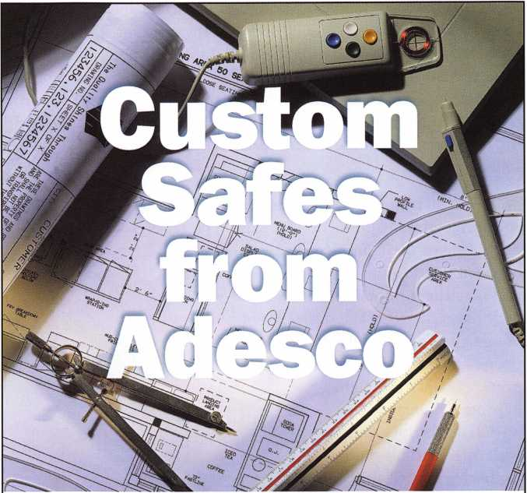

It is easy to customize a stock safe or  
design from the ground up with Adesco.

Here's how it works: Simply contact Adesco with your design  
needs. We will engineer the unit and work up a retail price.  
Once approved, call your distributor and place the order.

It's that easy!

2004 catalog available now.

Visit our web site  
to locate the Adesco  
distributor nearest you.

**adesco safe**

manufacturing co.

(800) 694-9340 • [www.adesco.com](http://www.adesco.com) • [safes@adesco.com](mailto:safes@adesco.com)



s

Keynotes • March 2004

**2**

From the first transponder-equipped vehicle to hit the  
road, locksmiths have been plagued with the need for  
tools and instructions on programming these vehicles.  
Over the last several years, my colleagues and I have  
done our best to keep you informed on this ever-  
changing technology; up till now, this evolved around  
the introduction and use of aftermarket programming  
tools.

Still, with all of the new tools and information avail-  
able, programming problems still exist. The most

perplexing of these problems is the lag time  
between the ongoing technological changes and  
access to the information and tools for working  
with these changes. The onslaught of program-  
ming-failure phone calls received with

the new-year vehicle introductions is a

prime example. Now, changes  
in programming and soft-  
ware send the locksmiths  
with original tools scurry-  
ing back to the dealers and  
distributors with fists full of  
money for the latest updates.

Despite all of the advan-

tages offered in a  
multi-manufacturer

tool, locksmiths owning aftermar-  
ket transponder programming  
units are sent reeling until the  
manufacturers have the time to  
research (and then backwards  
engineer) all of the new systems.

In fact, although it’s been available in Europe for some time (and in North America for about the last four or five years), the notorious “CAN” system has sent the aftermarket tool manufacturers on a rollercoaster ride of programming successes and failures. Even with the benefit of advanced notice afforded the Original Equipment Manufacturers (OEM), finding updated

software and hardware usually lags a good number of  
months behind the introduction of the new vehicles.  
Needless to say, locksmiths owning tools from either  
camp find themselves frustrated when asked to  
explain their inability to program the latest model  
vehicle with their expensive programming tool.

So, What Is CAN?

CAN is an acronym for “Controller Area

Network.” Despite its relatively new  
emergence in automotive control,

this technology has actually been  
around since the mid-1980s,

when it was first developed  
by Bosch. Since then, the

CAN protocol has  
gone through several  
versions and is used in  
various forms for  
industrial automation.

For auto manufacturers, the  
turn to the CAN protocol offers

several benefits. Today’s standard system configura-  
tions employ protocols that require dedicated, point-  
to-point wiring. Under such systems, a separate wire is

used for carrying specific data from one module, or  
point, to another. As such, these systems require

intense quantities of wire. (See illustration 1.)

Using the CAN protocol, however, communication  
between all modules and/or systems can be accom-  
plished over a single serial bus or cable, drastically

reducing the amount of wire needed to accomplish  
the same tasks. An added benefit of reduced wiring is

the dramatic reduction in weight and space for accom-

plishing the same tasks that current systems provide.

(See illustration 2.)

What makes all this possible? Well, without getting

too technical, the CAN protocol provides several

unique characteristics to all modules or systems so

CAN program­ming, simply pull the standard VIM and software card(s) out from the NGS and replace them.

Automotive Locksmithing

Transponders — Kicking The CAN

By Tom Seroogy



Keynotes • March 2004

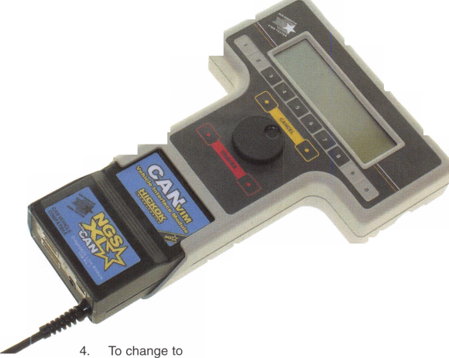

Module 5

they can communicate with each other over a single line. Aside from the high-speed communication capabilities of this protocol, the two most important features include frame identification and frame arbitration.

In short, a frame is a packet of information that is pro­duced by a sensor or a module and output to the net­work over the serial bus. The frame passes over the net­work and is detected and read by all devices attached to the network. However, only the device or module recog­nizing the frame’s identification will read and process the information contained in the frame. All other devices will ignore the frame, recognizing that the information was not meant for that device.

The arbitration feature dictates the priority a frame is given when released to the network. As the frame or data is being prepared for release onto the network, the network is checked for the transmission of an existing frame or data and the priority level of that data or frame. If two frames are released at the same time, the one hav­ing the lower arbitration is given the higher priority and first access to the network. The frame with the higher arbitration is given the lower priority and its transmis­sion is stopped until the network is clear.

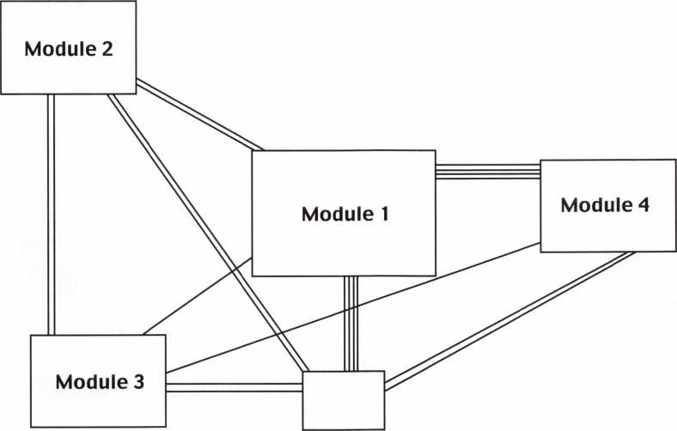

1. The standard module or sys­tem configuration involves a sepa­rate point-to- point wiring con­figuration.

The new CAN VIM, Vehicle interface Module and CAN software card.

Module 5

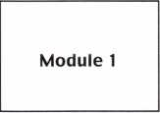

Module 2

Module 3

Module 4

2. With CAN, a single serial bus or wire can be used for all modules to communicate.

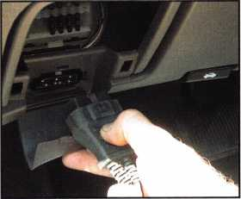

5.

Connect the DLC to the vehicle



Keynotes • March 2004

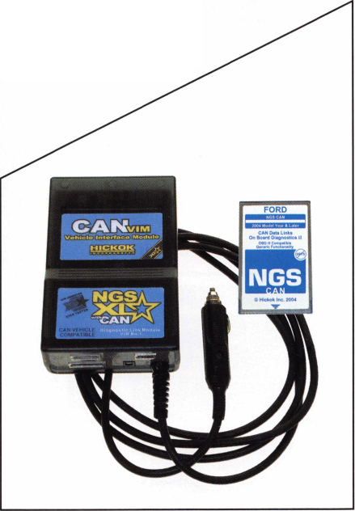

Step-By-Step CAN Programming

8. Select and trigger ENTER SECURI­TY ACCESS

From this point on, programming is identical to the standard NGS. Begin by selecting and triggering SERVICE BAY FUNCTIONS

7. Then select the module. Here, it is PCM.

SFfiPE KCV SW

SELECT ner, TfilQnSR TO

9. Choose your vehi­cle year and model.

Choose the key programming func­tion of your choise and the job is com­plete.

ACCESS DELAY : 10 MINUTES.

10.



Wait for the 10- minute security delay tolapse.

Keynotes • March 2004

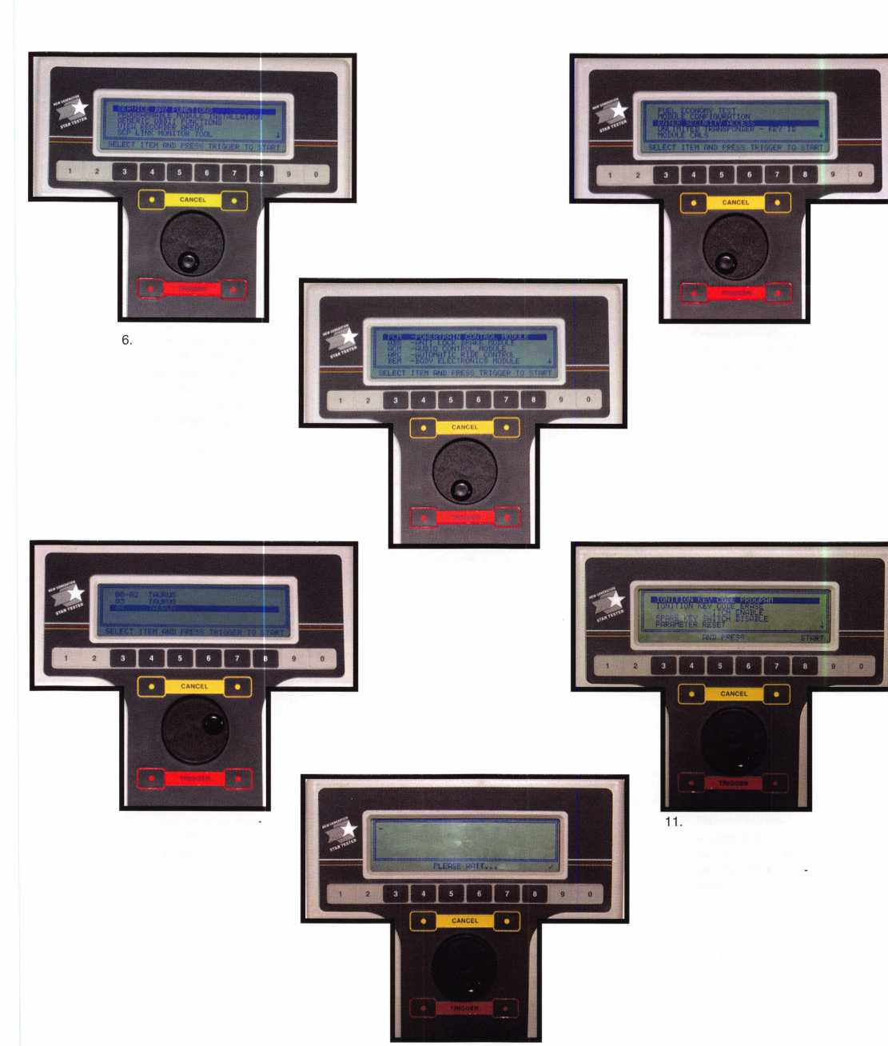

So, What Does This All Mean?

OK, so what does all this mean to the locksmith?

Well, only that the tools for programming transpon­ders may be a step behind, making some vehicle key programming impossible to our trade. GM, for exam­ple, is scheduled to use a “Single Wire CAN” system in place of theJi85oVPW protocol it currently uses. Although it’s a variation of the standard GAN system, tool manufacturers will have to make engineering con­siderations when developing for the new system.

Making matters worse, a manufacturer may employ more than one system or protocol in any given model. Nissan, for instance, has used the CAN protocol for some time, but only used it for modules controlling certain systems. And, up until recently, the key pro­gramming function was located in a module not con­nected to the CAN.

Ford, too, is producing vehicles that employ both CAN and J1850PWM protocols. Which system is used for key programming is dictated by the module that stores the PATS or transponder key program­ming instructions.

According to a release provided by Hickok, Inc., man­ufacturer of Ford’s NGS, the number of Ford models produced with CAN are 50 percent for 2004 and moving to 100 percent by 2007.

According to the release, the following Ford vehicles have the PATS programming located in modules using the CAN protocol:

* 2003 Focus with 2.3L engine
* 2004 F150 (except F150 Heritage)
* 2004 Explorer
* 2004 Mountaineer
* 2004 Taurus
* 2004 Sable

Fortunately, although future vehicle releases promise more problems, the aftermarket SDD, T-Code and Code-Seeker have already addressed most current CAN-related issues, and can be used to successfully program the keys for the most common North American vehicles equipped with transponder technology.

For users of the Ford Original Equipment NGS tool, there’s no need to worry Hickok will soon be intro­ducing an adapter and software allowing the current NGS to be used on all CAN. Although not scheduled for release until the middle of March, I was able to get a sneak preview and short demonstration of the new system.

The adapter, known as the CAN VIM or “Vehicle Interface Module,” is the lower and removable elec­tronic portion of the NGS, and is swapped out with the current VIM when programming a CAN- equipped vehicle. (See photograph 3.)

To use, simply pull out the standard VIM and Service or Diagnostic card, and plug in the CAN VIM and CAN card. (See photograph 4.) Use the standard VIM for programming the standard Ford systems.

From here on, simply plug the DLC into the OBDII port and follow the standard six-step key program­ming procedure used for programming all PATS II- equipped Ford vehicles. (See photograph 5.)

So, what is all this going to cost? A complete NGS XL kit that includes both the standard and CAN VIMs, plus two additional software card updates is around $3,000. For current owners of the NGS, the CAN VIM and software card will run about $600. (See photograph 12.)

For more information on the NGS XL and CAN VIM, contact a Hickok distributor. Tom Seroogy can be contacted at [tgseroogy@hotmail.com](mailto:tgseroogy@hotmail.com).

About the Author: Tom Seroogy is a 20-year locksmith specializing in automotive and access control. He is co-author of "The National Locksmith Guide to Basic Master Keying/' "Saber Tool Company's Guide to Ford Transponder Systems/' "The National Locksmith's Guide to GM Steering Column Service/' as well as BWD's manual series on GM VATS service. Seroogy is the founding editor of The National Locksmith Automobile Association and has been a contributing author to Keynotes, The National Locksmith and Locksmith Ledger. He is author of numerous articles on general locksmithing, access control, basic electronics, general automotive, high-security automotive, keyless remotes, automotive diagnostic tools and techniques, and transponders. Seroogy is an ALOA ACE certified instructor and has taught various locksmith related courses around the country. Seroogy has served on the sales and prod­uct development teams with STRATTEC, BWD (formerly All Lock), and, most recently Lockmasters. He is the founder, developer and former director of Lockmasters' PUREAuto Automotive training program. Seroogy is currently pur­suing a career in forensic/investigative automotive locksmithing. You can con­tact Seroogy at [tgseroogy@hotmail.com](mailto:tgseroogy@hotmail.com).



Keynotes • March 2004

The title of this article sounds like a great title for a  
book! That’s because it is the title of a book, an out-  
standing book written by Jerome V. Andrews, CML.  
This book, first copyrighted back in 1990, has been  
used as the course outline for many master keying  
classes, and is a great primer on master keying.  
Jerome’s resume is extensive, from

his BA and graduate studies to his  
time as key records manager for  
Lori and Kaba, to writing for  
Keynotes, and as board member

for ALOA. Most of what I’ve  
seen taught and written about  
pertains to total position pro-  
gression. Some on rotating  
constants, but it’s usually not  
emphasized or listed as an  
advanced concept. Jerome’s  
book explains the differ-  
ences between rotating con-  
stants and total position pro-

gression. Before explaining progressing, he covers how  
to design systems, key coding, the mechanics of mas-  
ter keying and many other important aspects related  
to master keying. Although I felt I had a pretty good  
grasp of total position progression, rotating constants

has always been a little difficult for me to trust my  
skills enough to write about it. I prefer to handwrite  
systems instead of using a computer. The flexibility  
offered by handwriting, and the understanding that  
comes with handwriting a chart, is important. I’ve  
watched others who only use a computer, and they’re

lost if something goes wrong.

Like many of you, I learned master keying in steps  
from several different people, and instructors. Some

Book Review:  
Fundamentals

of what I learned was good, and a lot was not so good.  
The first thing I learned was how to take a plug and  
stick bottom pins and match the change key, and then  
stick the master key in and fill the chambers with  
wafers to the shear line (not so good). Next, I learned  
that a good master key system will never have a cut

common between the master key and  
the change key (not true). In his book,  
Jerome offers a thorough explanation  
of total position progression, and

also rotating constants; he does  
it all in a well-thought-out format.  
He reinforced the good  
I learned many years ago

and corrected a few of my short-  
comings.

Over the years, I started learning  
why the rules originally taught to

me were wrong. I took a few  
classes, read some articles and a

couple of books. Slowly, the lights started to come on,  
and one day, the whole concept of progression using  
total position progression became clear. Fundamentals  
of Master Keying turned the lights on for me regard-  
ing rotating constants. Most of us are taught total  
position progression starting with one chamber, and  
then adding chambers until we have progressed  
through all the chambers. An example is that a five-  
pin progression chart for Schlage will result in 1,024  
theoretical changes. Then we are told if we need fewer  
change keys to “just not progress all the chambers.”

Jerome’s book explains the differences between rotat-  
ing constants, and total position progression. He  
explains that anything less than all the chambers pro-  
gressed is rotating constants. Rotating constants is

Jerome Andrews’ of Master Keying

By Greg Perry, CML, CPS



Keynotes • March 2004

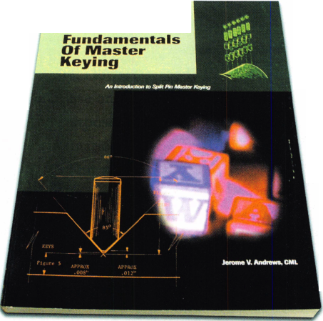

simply maintaining one or more of the chambers the same as the top master key, or not progressed. Instead, the location of progressed chambers is rotated. This means at least one position and often two or three of the positions will share the same cut as the master. Once again, another one of those poorly taught or understood concepts on my part, proven wrong.

If both rotating constants and total position progres­sion are acceptable, why not learn one and stick with it? Simple: They both have advantages and disadvan­tages. Rotating constants means fewer master pins or wafers in a lock; fewer master pins mean fewer chances of a stray key from outside the system operat­ing a lock. It also means the lock is more secure against picking. The disadvantage comes in the form of fewer incidental master keys. These are master keys that operate groups of changes within the system. In general, total position progression works better for more complicated systems. Rotating constants will generate more changes within a system, again at the expense of incidental master keys, but if you simply need a two level system, change keys and a master key, it’s the best method. Depending on your needs Jerome explains how to divide the key and create a three-level system with two levels of master keys using rotating concepts.

One more benefit of learning rotating constants is the ability to further progress a system. Occasionally, a customer might need only two or three chambers pro­gressed for their system; later, their needs may grow. If you are not familiar with how to rotate the constants, this could mean a new system, but using rotating con­stants means you’ll have plenty of changes available.

Any book on master keying would not be complete without covering many other topics. Before covering progression methods Jerome explains system struc­ture, key coding systems and record keeping. The mechanics of how a cylinder is master keyed and MACS (or maximum adjacent cut specifications) are well covered. Also, Jerome explains how to design the

top master key. A topic I haven’t seen covered in mag­azine articles that is covered in the Fundamentals of Master Keying is the methods of writing the bitting list. As Jerome points out, this is not the same as the progression chart. The basic difference is that the progression list is all the possible combinations avail­able within a system. The bitting list is all the combi­nations in use. The bitting list may be written in on of the three different formats explained by Jerome. First is the list format; in this form, the combinations are written top-to-bottom, as a list. Standard progression format differs in that the combinations are written in groups of four, assuming o to 9 cut depths and two- step progression. There are then four groups of four, vertically and horizontally totaling 64 combinations on each page. Finally, matrix format is explained. Jerome explains a crossword puzzle is a matrix. Using a matrix is simply a different way of laying out the form. It looks like a graph. The cuts on the key are selected by choosing a cut (or cuts) from the top of the graph, and a second cut (or cuts) from the side; where they intersect on the graph is marked with the standard key code. It works well for many applica­tions. Medeco uses the matrix format of writing the bitting list.

Fundamentals of Master Keying should be not just a required read, but required understanding and compre­hension for anyone involved in master keying. It has changed some of my thinking. I now write systems using rotating constants much more often and look at using rotating constants first instead of handwriting a system using total position progression. Fundamentals of Master Keying is available from the ALOA store, or take Jerome’s master keying class at the convention in Baltimore; the book will be included as the course outline.

About the Author: Greg Perry, CML, CPS, has been in the locksmith industry for 20 years. He's spent half of that time as a field technician for Security Engineering in Ridgecrest, CA. Greg is also a past president of the Desert Counties Chapter of the California Locksmiths Association. He has also won the 2002 and 2003 Keynotes Author of the Year Award. You can e-mail him at [glm- perry@iwvisp.com](mailto:glm-perry@iwvisp.com).

Keynotes • March 2004

**MEMBERSHIP APPLICATION**



Welcome to the Associated Locksmiths of America, Inc., an association for persons involved in the security industry as  
locksmiths, security consultants, educators, manufacturers and distributors.

To apply for membership, please complete this application and submit it with the dues for the current year, and your  
business card, company letterhead, or other suitable proof of employment.

All of the following questions MUST be answered before this application may be processed. Please type or print.

TYPE OF MEMBERSHIP

Please check only one.

* ACTIVE MEMBERSHIP Individuals actively engaged in supplying, servicing, or installing security hardware for a period of not less than two years.
* APPRENTICE MEMBERSHIP Individuals who are in initial train­ing and meet all the requirements for Active Membership except for the length of time in the security industry.
* ALLIED MEMBERSHIP Individuals whose position in the security industry relates to the aims, policies and promotion of the locksmith and his/her craft.

APPLICATION AND FEES

A $50 application fee, appropriate annual dues, and your business card, company letterhead, or suit­able proof of employment must accompany this application. Your second year's dues will be prorated based on the date your application was received by ALOA.

FINAL CHECKLIST us

Dollars

* Application Fee 50.00

ANNUAL DUES STRUCTURE

* Active/Allied Member 155.00 U.S. + U.S. Territories

(PR, VI, Guam]

* Active/Allied Member 1 30.00 Non U.S. Resident or

Non U.S. Territories

* Apprentice Member 80.00

U.S. and International

OTHER FEES

* Canadian Air Mail 20.00
* Overseas Air Mail 50.00

Total Enclosed

Return to  
ALOA

**3003 Live Oak Street  
Dallas, TX 75204-6185  
(214)827-1701**

CANDIDATE (PLEASE TYPE OR PRINT)

|  |  |  |  |
| --- | --- | --- | --- |
| **Name □ Mr. □ Mrs. □ Ms.** | | | |
| **Business Name** | | | |
| **Mailing Address** | | | |
| **City** | **State** | **Zip Code** | **Country** |
| **Work Phone** | **Home Phone** |  | **Fax** |
| **Email Address** | **Website** |  |  |
| **Date of Birth** | **Social Security Number** |  |  |
| **Directory Address (if different than** | **mailing address)** |  |  |
| **City** | **State** | **Zip Code** | **Country** |

□ Do Not List in Directory

PROFESSIONAL INFORMATION

1. Are you a...

* Sole Owner □ Corporate Officer
* Partner □ Employee □ Student

1. Are you currently employed in the security industry?

* no □ yes, years

1. How did you learn locksmithing or security work?

4. ALOA Sponsor

Sponsors ALOA Number

Please note, if you are sponsored by an ALOA member, your application will be immediately processed with a 90-day probation period. Otherwise, final processing fakes up to 120 days.

5. Names and addresses of two industry-relat­ed references (required):

*Name*

Address

*Name*

*Address*

6. IMPORTANT: Have you ever been convicted of a felony? □ No □ Yes

If yes, please give details on a separate sheet. All felonies are reported to the Membership Department for review.

METHOD OF PAYMENT

□ Check □ MasterCard □ Visa □ Discover □ American Express

|  |  |
| --- | --- |
| **Card Number** | **Expiration Date** |
| **Please print name as it appears on card** |  |

Cardholder's Signature

I certify that all statements are true and, if accepted as a member, I agree to abide by the rules, regulations, and Bylaws of ALOA, and further agree to  
adopt the Code of Ethics of ALOA as my own, and adhere to it to the best of my ability. Should my membership be discontinued, I agree to return my mem-  
bership card, and cease use of all ALOA insignia.

Signature

Date

Revised 1 2/03



RING of a KING

Name Members

Recruited

Kwok-kei Leung 215

Henry W. Raymond 100

Yuriko Yanai 82

Mary S. Ohmit CPL 66

Charles C. Robertson CML 65

Jack Hobin CPL 51

William Lee CRL 44

Salvatore J. Dulcamaro CML 41

C Allan Halverson 40

Michael B. Groves 39

Myeong-Rae Cho 38

Dana L. Barnum CML 35

Jim Williams CRL 33

Danny W. Rudd CPL 32

Larry A. Warnick CML 31

Eugene R. Altobella Sr 31

Jeanne G. Lodge CML 30

John C. Elliott Jr, CML, CPS 26

Robert D. DeWeese CML 29

Lawrence F. Smith Jr, CML 27

David M. Troiano 27

James M. Watt, CML, CPS 27

Marian M. Swann CRL 26

Robert F. Carroll CPL 26

Jeffrey S. Nunberg CML, CMS 26

J Thomas Hood CML 26

Robert W. Duman Sr, CML 25

Robert H. Stafford CML 25

John L. Shandy CML 24

Elvis D. Hammerschmidt CPL 24

Philip A. Rovenolt CPL 24

Jerome L. Cohen CML 23

Peter K. Gauthier CPL, CPS 23

Man-Soo Seo RL 23

Diana R. Barnum CRL 22

James J. Cawby CML, CPS 22

John S. Dorsey CML, CPS 20

Walter W. Lascar RL 18

Thomas G. Vandersteen CML, CPS.. 18

Keizo Takahashi CRL 18

James E. Fowler Sr, CML 18

David C. Harris CML 18

William T. Beranek 18

Takashi Kuwana CRL 18

Eugene R. Altobella Jr 18

James L. Hancock CRL 18

Ernest W. Wright 17

Peter R. Hall 17

William P. Grant CRL 17

James E. Gruber CRL 17

Joseph P. Ferrero CML 16

Gary F. Teams CPL 16

Kenneth E. Kim CRL, CPS 16

William J. McElheney CML 16

Joseph W. Whitaker CPL 16

Michael E. Jordan Jr, CML 16

Jon B. Griswold CML 16

Brian J. Reetz 16

John A. Ilk CRL, CPS 16

Russell P. Fuller CRL 16

Robert C. Rodocker CPL 15

Peter Sarailian CRL 15

Michael D. Robinson CRL 15

Daniel L. Landry Jr 15

Steve L. Cothron 15

Paul M. Souber 14

James T. Brickler CPL 14

Ken Dale 14

Joseph C. Fuller CML, CMST 13

Calvin G. Harris CML 13

Frank D. Hartung CML 13

Rolando Bouza 13

Donald H. Shiles RL 13

Richard C. Sievers 13

William J Wickward, CML 12

William J. Wickward CML 12

Raymond C. Lusk CML 12

John F. Engel CRL 12

Eric F. Veal 12

Thomas J. Demont CML, AHC 11

Basil W. Shannon CPL 11

Timothy K. Chow 11

Dale L. Knowles CPL 11

Timothy J. Moore CRL 11

Gregory L. Perry CML, CPS 11

James V. Hawley CRL 11

Gene Eldridge CPL 10

Ronald P. Riggins CML 10

Lester S. Brodsky 10

Ralph O. Warren CML 10

Larry L. Votaw CML 10

Thomas R. Smith CPL 10

Todd K. Ladwig CML, CPS 10

Kevin R. Wilson CML, CPS 10

William T. Straub CML 10

Richard T. Johnson CPL 10

Robert M. Massard CRL,AHC 10

Marian E. Sagar 10

Daniel S. Enriquez CRL 10

Brooke P. Berry CRL 10



How can I join the President's Club?

You can earn a membership in this prestigious club by recruiting  
just 10 new members for ALOA.

*Any ALOA member may participate.

What do I get?

When you recruit 10 members, you receive a  
handsome blue blazer with a President's Club crest.  
For each additional five members you recruit, you  
receive a lapel pin with gold-filled numbers, indicating,  
your recruiting successes.

You also get the satisifaction of knowing that you are  
helping your association, helping your industry grow,  
and you are helping fellow locksmiths achieve success.

How do I get started?

Mail the form below to the ALOA office for a supply of  
applications (800) 532-ALOA or FAX (214) 827-1810.  
One President's Club credit is awarded for each new  
applicant. Credit is awarded only after the membership  
application is pproved. However, the credit will apply  
for the period in which the application is received.  
Failure to identify yourself as the sponsor on the applica-  
tion form at the time it is submitted to ALOA for process-  
ing will forfeit any credit.

Yes! I want to join the ALOA President's Club.

Please rush me applications so I can start earning credit toward membership in the club!

Name

Company

Address

City

Zip

Mail this form to ALOA • 3003 Live Oak • Dallas, Texas 75204-6186



Arkansas:

A bill taxing the actual service of locksmithing was intro­duced at the last minute in the special session of Arkansas' legislative year. The Bill, AR HI030b was introduced by Assemblyman Boyd. A previous version seeking to tax all services in Arkansas was defeated and HI 030b was quickly formulated to target a few groups. ALOA sprung into action and joined forces with the Pest Control Association (another affected group) to stage a last minute coup. Unfortunately, greed and fiscal irrespon­sibility won out when an amendment to strike locksmiths and pest control workers from the legislation failed by one vote in committee.

New Jersey:

Applications for locksmith licensing began circulating recently. The cost for a license will be $150.00 and fin­gerprinting (currently $68.00) will also be necessary. There is no deadline for when these applications currently are due. In fact, the exact rules and regulations have not even been promulgated yet. When they are received, they will be held until the state finishes processing burglar alarm licenses. At that point, a letter will be automatically sent out, advising the applicant when and where they can get fingerprinted. If you have any questions regarding the legislation, or would like to learn about committee meet­ings, grandfathering or exam exemptions, please visit NJ on the web at [http://www.state.nj.us/lps/ca/nonmed- ical/electrical.htm](http://www.state.nj.us/lps/ca/nonmed-ical/electrical.htm)

You may also call George DeLuca with the licensing board at (973) 504-6410

Mississippi:

Senate Bill 2322 was recently introduced calling for the licensing of anyone involved with the servicing and/or installation of burglar alarm systems. ALOA has closely monitored the situation and made sure that all definitions within the law are beneficial to locksmiths. The law DOES NOT affect a locksmith's ability to install or repair non- monitored systems.

Chapter & Affiliate News:

The Oahu Chapter of ALOA has officially begun! The Chairman's name is Wayne Lockhart. They meet on the first Tuesday of every month at Aloha Lock and Key. For more information please call 1-808-593-91 14 or email them at [alohakey@gte.net](mailto:alohakey@gte.net)

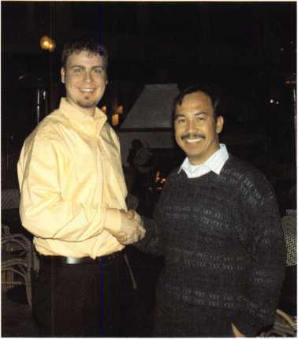

ALOA would like to congratulate John Choko, who was recently named Chairman of the San Diego Chapter of ALOA! John has big plans for growing the membership and instituting a strong educational environ­ment. Please feel free to call him at 1-619-823-0073 for more information.

Keynotes • March 2004



***Visit our Website on  
www. stamcctv. com***

THE COMPLETE

CCTV PROGRAM ON CD-ROM  
FOR STAFF TRAINING AND

PRODUCTIVITY ENHANCEMENT

STAM **Insight** has been  
developed to enhance CCTV  
skills and productivity with  
many different uses.

Productivity

System Drawing I# Estimation # CCTV Training CCTV Reference Sales/Demo W System Design Staff Evaluation

**14 hours**

CCTV Calculators

Demonstration Tool

Estimation

Drawing

Internet Enabled

^knowledge Assessment

CCTV Content

**Sold in Over 50 Countries**

Distributed by:



3003 Live Oak Street  
Dallas,Texas 75204

■ Yes, please send me a FREE PREVIEW CD ROM $9.95 S/H

Name:

Job Title:

Organization:

Address:

..Zip/Postcode..  
..e-mail

Fax: ( )

COPYRIGHT © 1996 Security Training and Marketing Pty Ltd. All rights reserved ACN 057 006 541

Country

Tel: ( )

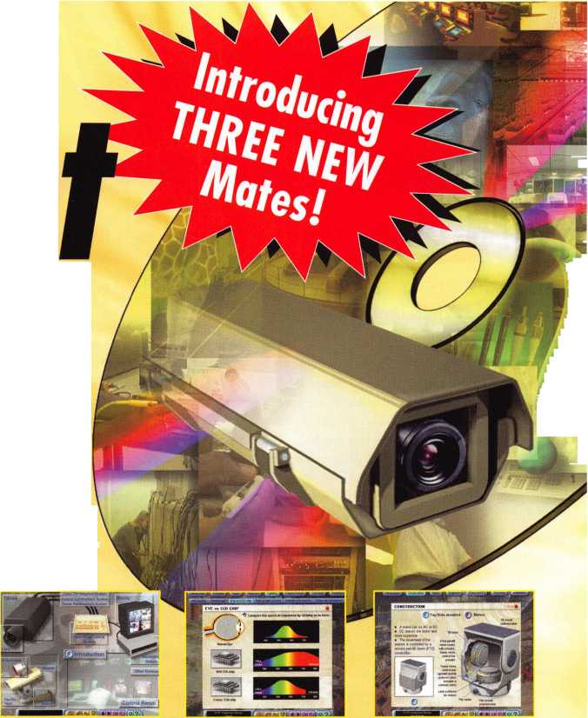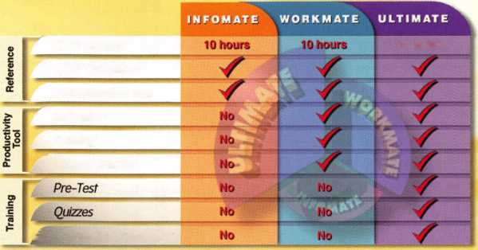

Classifieds



EMPLOYMENT

FKI SECURITY GROUP SEEKS QUALIFIED TECHNICIANS FOR NEW FIELD SERVICE DIVISION

In response to continuing and growing demand for field service, FKI Security Group has estab­lished the FKI Field Services division to support NKL Cash Handling products and is seeking qualified technicians in major metro markets. Technicians will support business development and new service contracts for NKL Cash Handling, which include electronic bill-counters or validators, dispensing safes and access con­trol safes. Each field technician will be equipped with a state of the art communications system and all the necessary parts and tools to service all of FKIis security products.

The markets currently open are, Baltimore/ Washington DC, New Jersey/Metro New York, North/Central Ohio, Dallas, Houston, Orlando/ Central Florida, Northern California, Sacramento/ East Bay, Southern California, Phoenix

Highly competitive compensation and a com­plete benefits package including health, dental, and vision insurance, 401 K plan, and fully paid expenses will be offered to qualified technicians. Technicians with the experience servicing safes, locks, ATMs or POS systems will be considered. This position can grow into a management position as the division expands.

Interested parties should contact Christina Lyell at 800-457-2424 or e-mail your resume to [chrisl@fkisecuritygroup.com](mailto:chrisl@fkisecuritygroup.com)"



101 Security Parkway • New Albany, IN 47150

PROFESSIONAL EXPERIENCED TECHNICIAN(S) WANTED:

We are in need of 1 to 2 technicians with the ability to Sell, Install, and Service all major mfg. Hardware. We are located in Knoxville, Tennessee and service all areas of east and mid­dle Tennessee. Must have a clean criminal and driving record. Must have professional attitude and appearance. Background check and References must be supplied. Must be experi­enced in commercial, industrial, and residential hardware sales, service and installations.

Access and other areas is a plus.

Paid Holidays, Retirement, Health insurance, uniforms, tools and truck supplied. 8-5pm Monday thru Friday.

Ph# 800-484-5577, pin 0841 Fax# 865-637-2359 E-Mail: [info@fmgeorge.com](mailto:info@fmgeorge.com)

LIVE AND WORK IN PARADISE!

A 20-year-old mobile business that has not yet peaked - owner retiring. Located in beautiful Lake Arrowhead, CA. State-of-the-art 2003 GMC AWD 2500 Savannah Van. ITL950C computerized code key machine. Rytan RY100 high-speed key machine. Office furniture, note­book, computer and equipment. Commercial and residential accounts. Can also include 3BR/3BA lake view home. Serious inquiries only, please. I AM NOT PARTING THIS OUT. 909/337-8254 cell 909/295-3310

WANTED

Experienced Locksmith. Established and expand­ing company in central New Jersey is seeking experienced help in residential/commercial/ auto/access control/safe work. Top pay for top mechanics along with medical, dental, paid vacation, no night calls. Call 732-970-1500, or fax resume to 732-970-9725, attn. Andy or Jack.

JOIN OUR PROUD TEAM!

The Broward County Sheriff's Office Is Hiring in Sunny South Florida!

Besides our location in paradise, South Florida is a mecca of culture, beautiful beaches, and recreational advantages. Join our 5,000-member team, America's largest nationally accredited Sheriff's department, and enjoy the excitement and benefits of South Florida living including No State Income Tax!

MAINTENANCE SPECIALIST (Locksmith)

$29,731 -$43,926

In this position, you will perform a wide variety of locksmith and general trade related duties in a detention facility environment. This may include installation, maintenance and repair work involving highly sophisticated state-of-the- art systems designed to support effective and efficient corrections operations. Qualifications include a high school diploma or equivalent (GED), three years experience and/or training in locksmith work, a valid Florida's driver's license.

Department of Motor Vehicles certified seven (7) year driving history dated within one month of application date required with application. If you're qualified and interested in building a great career in South Florida, please contact us at 888-BSO-STAR or visit [www.sheriff.org](http://www.sheriff.org). EOE M/F/D/V DFWP

BSO is an equal opportunity employer and does not discriminate based on age, citizenship sta­tus, color, disability, marital status, national ori­gin, race, religion, sex, or sexual orientation. Veterans' preference per Florida law.

Classified Advertising Policy

Classified advertising space is provided free of charge to ALOA members, and for a fee of $.60 per wordf, $15 minimum for non-members. Classified ads may be used  
to advertise used merchandise and overstocked items for sale, "wanted to buy" items, business opportunities, employment opportunities/positions wanted and the like.  
Members or non-members wishing to advertise services or new merchandise for sale may purchase a "Commercial Classified Ad" for a fee of $1.30 per word, with a  
minimum of $40. Each ad will run for two issues. For blind boxes there is a $5 charge to members and non-members. All ads must be submitted in writing to the ALOA  
office by the fifteenth of the month, two months prior to issue date. Send to Keynotes Classifieds, 3003 Live Oak St., Dallas TX 75204-6186. ALOA reserves the right to  
refuse any classified advertisement that it deems inappropriate according to the stated purpose of the classified advertising section.

STOP LOOKING!!

EXPERIENCED TECHNICIANS WANTED Lock into your future now! If you are experienced, intelligent, and desire a secure future, come join our team. We are a full service commercial/residential security service (locks, keys, safes, CCTV, access control, door-related hardware). We offer top wages, company vehicle, 401k, paid vacation, paid holidays, new uniforms, cross training, and job satisfac­tion. We are looking for the best techs, who are ready to be treated and com­pensated as professionals.

Bass Security Services, Inc. 216-755-1200, XI28 Fax 216-755-1220 e-mail: [rmesnick@bass-security.com](mailto:rmesnick@bass-security.com)

WANTED TO BUY/SELL

FOR SALE

Original Schlage blanks in 5-pin EF keyway or 6-pin in CE, EF, FG or G keyway at $ 1 2.50 per box of 50. Contact George Thomas at 21 8-724-3416 or write to 825 Woodlandd Ave., Duluth MN 55812-2168

WHOLESALE SAFE DEPOSIT LOCKS

Allied, Diebold, Herrin, Hall & Mavin, llco, Lefabure, Mosler, Precision, S&G, Security Corp., Yale. Locks from early 1900s to current. Call or email for lock type and pricing sheet. Quantity discounts. Call WBI at (954)484- 2404 or email: [sales@wbi.us](mailto:sales@wbi.us)

FOR SALE

Owner retired. Framon Model 2 w/ manual and Scotsman Model 747XU w/ manual.

Like new. Reed code books 1, 2, 3, 4 and 5. Call 919/676-8490.

WANTED TO BUY

Automotive transponder equipment wanted. Triax machine, T-Code, TCL, EDT Jr., RW2,

A-l Pack-a-Punch. Call 877/41 1-5397 and ask for Bob.

FOR SALE

Abloy Dislock key machine and all equipment needed to service Abloy locks and padlocks. Included are discs, master discs and spacers for rekeying; service kits; books, instruction books, and misc. info is also included. Abloy Dislock locks, new and used, with key blanks and many parts and service equipment too numerous to mention. Please call for details: 267-337-0975. E-mail: [bdstevenso@aol.com](mailto:bdstevenso@aol.com).

FOR SALE

Used Equipment. Here is just a sample (call for dimensions of items): Tann TL-30 Composite,

RS, $1000. Two Major TL-30 plate safes with small interior safe right swing, $500. Collier TL-15 plate left swing, empty, $1000. Mosler UL Class 350 fire door right swing, $950. Mosler TR TL, interior has five lockers and two shelves, $2500. Collier Class 2 vault door, right swing, $2000. Diebold Cash Guard, TL- 15 with four lockers, $600. Used night deposi­tories, safe deposit boxes, lockers, etc. Prices do not include shipping, [www.thistlesafe.com](http://www.thistlesafe.com). Call 781-324-1600. E-mail [thistlenl@aol.com](mailto:thistlenl@aol.com). Service and rigging available to manufacturers and dealers for the greater Boston area.

FOR SALE: FULLY-EQUIPPED LOCKSMITH VAN

1998 Ford Encoline E-150, 81,679 miles, new tires, tinted windows. Key machines, inverter, wooden workbench, cabinets, pegboard, basic locksmithing tools and complete set of car opening tools, all included. Call 319-266- 7486 for more info, or e-mail [polkslock@cfu.net](mailto:polkslock@cfu.net).

FOR SALE

28 year-old established, well-equipped mobile locksmith business available due to age and health. Metro Denver. Contact for details: phone: 303-759-75000 • Fax: 303-730-2264 e-mail: [stanl926@gwest.net](mailto:stanl926@gwest.net)

BUSINESS FOR SALE

BUSINESS FOR SALE

A small, quite successful business for sale in south Orange County, California. Three Rytan machines, three HPC code machines, HPC code books, coding program, tools for "luxu­ry" vehicle lockouts - all parts, tools and sup­

plies to keep two trucks on the road full time. One truck on the road provides $10-1 1 K per month. Truck, which is the Ford F250 van with advertising signage, built-in work areas and cabinetry - can be part of the package or pur­chased separately. Low operating costs after 10 years of building the business. Advertising expenses 10 years ago? $4K per month. Now we pay a fifth of that. This is a nice set-up for someone to step in and take over. Existing accounts (which bring in about $8200/month include three in property management and eight auto dealerships. Well work to set you up with our existing accounts.

All reasonable offers will be considered.

Call 949/370-9619, or fax 949/458-1733.

MOBILE LOCKSMITH BUSINESS FOR SALE

Speedex duplicator, van, tools, code books, two HPC code machines (Blitz), inventory, some hardware. $6000 (firm).

Call 601/916-6448.

LOCKSMITH FRANCHISE AVAILABLE

Low cost, complete training, national Franchise call (925) 260-7373 • [www.SpeedyLocksmiths.com](http://www.SpeedyLocksmiths.com) .

CENTRAL OREGON COAST

Well-established Lock Shop with 50 -mille AAA Contract, 24-hour Mobile Van Service, Commercial, Residential and Turn-Key Auto Shop. No pun intended! Owners will train and/or assist with the transition of this busy shop with a great location on Highway 101 in the heart of Coos Bay. Cash or contract terms. Call Realty Solutions LLC • Ellie Cairy 503- 620-5533



SAFE CORPORATION

MANUFACTURES OF QUALITY DEPOSITORY SAFES AND CHESTS

DISTRIBUTING FROM

WAREHOUSES IN

* LOS ANGLES**,** CA
* CHICAGO**,** IL
* GLASSBORO, NJ

A & B is now a stocking distributor

for Mutual Safes

featuring ^w j

jilm mg

il

hi

L*

m

AB-4-30-3S AB-9-2 WS 10-2

Chose from over 75 models in stock

We ship your order within

24 hours

See us

*at [www.a-bsafecorp.com](http://www.a-bsafecorp.com)*800-253-1267  
Fax 856-863-1208

CALL FOR YOUR  
CATALOG TODAY



associate

members

Distributor

**ADI Inc**

Phone: 631-692-1000 Fax: 631-692-301 1

**Accredited Lock Supply Co.**

Phone: 800-652-2835 Fax: 201-865-0030 [www.acclock.com](http://www.acclock.com)

**Ace Lock &**

**Security Supply**

Phone: 800-223-5625 Fax: 908-688-2442 [www.acelock.com](http://www.acelock.com)

**Andrews Wholesale Lock Supply**

Phone: 717-272-7422 Fax: 717-274-8659 [www.andrewslock.com](http://www.andrewslock.com)

**Boyle & Chase Inc.**

Phone: 800-325-2530 Fax: 800-205-3500 [www.boyleandchase.com](http://www.boyleandchase.com)

**Clark Security Products**

Phone: 800-854-2088 Fax: 619-974-5284 [www.clarksecurity.com](http://www.clarksecurity.com)

**Cook's Building Specialties**

Phone: 505-883-5701 Fax: 505-883-5704

**Dire's Lock &**

**Key Company**

Phone: 303-294-0176 Fax: 303-294-0198

**Direct Security Supply, Inc.**

Phone: 800-252-5757 Fax: 800-452-8600

**Doyle Security Products**

Phone: 800-333-6953 Fax: 612-521-0166 [www.doylesecurity.com](http://www.doylesecurity.com)

**Dugmore and Duncan, Inc.**

Phone: 888-384-6673 Fax: 888-329-3846

E. **L. Reinhardt Co., Inc.**

Phone: 800-328-1311 Fax: 651-481-0166 [www.elreinhardt.com](http://www.elreinhardt.com)

**Fairway Supply, Inc.**

Phone: 214-350-0021 Fax: 214-352-4299 [www.fairwaysupply.com](http://www.fairwaysupply.com)

**Foley-Belsaw Company**

Phone: 800-821-3452 Fax: 816-483-5010 [www.foley-belsaw.com](http://www.foley-belsaw.com)

**Fried Brothers Inc.**

Phone: 800-523-2924 Fax: 215-592-1255 [www.fbisecurity.com](http://www.fbisecurity.com)

**Hardware Agencies, Ltd.**

Phone: 416-462-1921 [www.hardwareagencies.com](http://www.hardwareagencies.com)

**IDN Incorporated**

Phone: 817-421-5470 Fax: 817-421-5468 [www.idn-inc.com](http://www.idn-inc.com)

**Intermountain Lock & Supply**

Phone: 800-453-5386 Fax: 801-485-7205 [www.intermountainlock.com](http://www.intermountainlock.com)

**Jo Van Distributors**

Phone: 416-752-2238 Fax: 416-752-7282 [www.jovanlock.com](http://www.jovanlock.com)

**Locks Company**

Phone: 800-288-0801 Fax: 305-949-3619

**M. Zion Company**

Phone: 212-349-8677 Fax: 212-964-0495 [www.mzion.com](http://www.mzion.com)

**McDonald Dash Locksmith Supp**

Phone: 800-238-7541 Fax: 901-366-0005 [www.mcdonalddash.com](http://www.mcdonalddash.com)

**Omaha**

**Wholesale Hardware**

Phone: 800-238-4566 Fax: 402-444-1664 [www.omahawh.com](http://www.omahawh.com)

**RA-Lock Company**

Phone: 972-775-6301 Fax: 972-775-6316 [www.ralock.com](http://www.ralock.com)

**Security House**

Phone: 905-669-5300 Fax: 905-660-6313 [www.securilyhouselock.com](http://www.securilyhouselock.com)

**Security Lock Distributors**

Phone: 800-847-5625 Fax: 800-878-6400 [www.securadealer.com](http://www.securadealer.com)

**Southern Lock and Supply Co.**

Phone: 727-541-5536 Fax: 727-544-8278 [www.southernlock.com](http://www.southernlock.com)

**Stone & Berg Wholesale**

Phone: 800-225-7405 Fax: 800-535-5625

**The Locksmith Store Inc.**

Phone: 847-364-51 11 Fax: 847-364-5125 [www.locksmithstore.com](http://www.locksmithstore.com)

**Timemaster Inc.**

Phone: 859-259-1878 Fax: 859-255-0298 [www.time-master.com](http://www.time-master.com)

**Top Notch Distributors, Inc.**

Phone: 800-233-4210 Fax: 800-854-4146 [www.4topnotch.com](http://www.4topnotch.com)

**Turn 10 Wholesale**

Phone: 800-848-9790 Fax: 800-391-4553

**U.S. Lock Corp.**

Phone: 800-925-5000 Fax: 800-338-5625 [www.uslock.com](http://www.uslock.com)

Manufacturer

**A & B Safe Corporation**

Phone: 800-253-1267 Fax: 856-863-1208 [www.a-bsafecorp.com](http://www.a-bsafecorp.com)

**ABUS Lock Company**

Phone: 800-352-2287 Fax: 602-516-9934 [www.abus.com](http://www.abus.com)

**Adams Rite Mfg Co.**

Phone: 800-872-3267 Fax: 800-232-7329 [www.adamsrite.com](http://www.adamsrite.com)

**Adesco Safe Mfg. Co.**

Phone: 800-694-9340 Fax: 562-408-6427 [www.adesco.com](http://www.adesco.com)

**Adrian Steel Company**

Phone: 800-677-2726 Fax: 517-265-5834 [www.adriansteel.com](http://www.adriansteel.com)

**All Five**

**Tool Company, Inc.**

Phone: 860-583-1691 Fax: 860-583-4516 [www.all5tool.com](http://www.all5tool.com)

**American Lock Company**

Phone: 708-534-2000 Fax: 708-534-0531 [www.armericanlock.com](http://www.armericanlock.com)

**American Security Products**

Phone: 909-685-9680X1083 Fax: 909-685-9685 [www.amsecusa.com](http://www.amsecusa.com)

Keynotes • March 2004

associate

members

**Bianchi USA, Inc.**

Phone: 800-891-2118 Fax: 216-803-0202

**Buddy Products**

Phone: 800-886-8688 Fax: 312-733-8356 [www.buddyproducts.com](http://www.buddyproducts.com)

**CCL Security Products**

Phone: 800-733-8588 Fax: 847-537-1800

**COMPX**

**Security Products**

Phone: 864-297-6655 Fax: 864-297-9987 [www.nclnet.com](http://www.nclnet.com)

**D&D Technologies (USA), Inc.**

Phone: 714-677-1300X292 Fax: 714-677-1299 [www.ddtechusa.com](http://www.ddtechusa.com)

**DETEX Corporation**

Phone: 800-729-3839 Fax: 830-620-671 1 [www.detex.com](http://www.detex.com)

**DORMA Architectural Hardware**

Phone: 717-336-3881 Fax: 717-336-3500

[www.dorma-usa.com](http://www.dorma-usa.com)

**Datakey Electronics**

Phone: 952-746-4066X323 Fax: 866-289-4212 [www.datakeyelectrnics.com](http://www.datakeyelectrnics.com)

**Don-Jo**

**Manufacturing, Inc.**

Phone: 978-422-3213 Fax: 978-422-3467 [www.don-jo.com](http://www.don-jo.com)

**Door Controls International**

Phone: 800-742-3634 Fax: 800-742-0410 [www.doorcontrols.com](http://www.doorcontrols.com)

**ESP Lock Products Inc.**

Phone: 800-434-8960 Fax: 978-562-9859

**FireKing**

**Security Products**

Phone: 800-457-2424 Fax: 800-896-6606 [www.fkisecuritygroup.com](http://www.fkisecuritygroup.com)

**Framon Manufacturing Company Inc.**

Phone: 989-354-5623 Fax: 989-354-4238 [www.framon.com](http://www.framon.com)

**HY-KO Products Co.**

Phone: 440-232-8223X3095 Fax: 440-232-8227

**Hammerhead Industries, Inc.**

Phone: 805-658-9922 Fax: 805-658-8833 [www.gearkeeper.com](http://www.gearkeeper.com)

**Jet Hardware Mfg., Co.**

Phone: 718-257-9600 Fax: 718-257-0973

[www.jetkeys.com](http://www.jetkeys.com)

**KEY-BAK/West Coast Chain Mfg**

Phone: 909-923-7800 Fax: 909-923-0024 [www.keybak.com](http://www.keybak.com)

**Keri Systems Inc.**

Phone: 408-451-2520 Fax: 408-441-0309 [www.kerisys.com](http://www.kerisys.com)

**Knaack**

**Manufacturing Co.**

Phone: 800-456-7865 Fax: 815-459-9097 [www.weatherguard.com](http://www.weatherguard.com)

**LAB Security**

Phone: 800-243-8242 Fax: 860-583-7838 [www.labpins.com](http://www.labpins.com)

**Lock America, Inc.**

**Dba L.A.I. Gro**

Phone: 714-373-2993 Fax: 714-373-2998 [www.laigroup.com](http://www.laigroup.com)

**Lucky Line Products, Inc.**

Phone: 858-549-6699 Fax: 858-549-3241 [www.luckyline.com](http://www.luckyline.com)

**M.A.G. Security**

Phone: 714-891-5100 Fax: 714-892-6845 [www.magsecurity.com](http://www.magsecurity.com)

**MUL-T-LOCK USA, Inc.**

Phone: 800-562-3511 Fax: 973-778-4007 [www.mul-t-lock.com](http://www.mul-t-lock.com)

**Medeco Security Locks**

Phone: 540-380-5000 Fax: 540-380-5010 [www.medeco.com](http://www.medeco.com)

**ROFU**

**International Corp.**

Phone: 800-255-7638 Fax: 253-922-1728 [www.rofu.com](http://www.rofu.com)

**Rutherford Controls Inti. Co.**

Phone: 757-427-1230 Fax: 757-427-9549 [www.rutherfordcontrols.com](http://www.rutherfordcontrols.com)

**STRATTEC Security Corp.**

Phone:414-247-3415 Fax: 414-247-3692 [www.strattec.com](http://www.strattec.com)

**Sargent &**

**Greenleaf, Inc.**

Phone: 859-885-9411 Fax: 859-885-3063 [www.sargentandgreenleaf.com](http://www.sargentandgreenleaf.com)

**Sargent**

**Manufacturing Co.**

Phone: 800-727-5477 Fax: 888-863-5054 [www.sargentlock.com](http://www.sargentlock.com)

**Schlage Lock Co.**

Phone: 719-264-5300 Fax: 719-264-5382 [www.schlagelock.com](http://www.schlagelock.com)

**Securitron Magnalock Corp.**

Phone: 775-355-5625 Fax: 775-355-5636 [www.securitron.com](http://www.securitron.com)

**Security Door Controls**

Phone: 805-494-0622 Fax: 805-494-8861 [www.sdcsecurity.com](http://www.sdcsecurity.com)

**Security Solutions**

Phone: 405-376-1600 Fax: 405-376-6870 [www.securitysolutions-usa.com](http://www.securitysolutions-usa.com)

**Townsteel, Inc.**

Phone: 626-858-5080 Fax: 626-858-3393

**Trine Access Technology**

Phone: 718-829-2332 Fax: 718-829-6405 [www.trineonline.com](http://www.trineonline.com)

**Videx Inc.**

Phone: 541-758-0521 Fax: 541-752-5285 [www.videx.com](http://www.videx.com)

**YSG Door Security Consultants, Inc.**

Phone: 800-438-1951 Fax: 800-338-0965

Service

Organization

**Cross Country Automotive Services**

Phone: 800-541-2262 Fax: 781-393-0256 [www.argosi.com](http://www.argosi.com)

**Massglass &**

**Door Service**

Phone: 888-742-8837 Fax: 805-497-2255

[www.massglass.com](http://www.massglass.com)

**Webster Safe & Lock Co., Inc.**

Phone: 901-332-2911 Fax: 901-332-2878 [www.webstersinc.com](http://www.webstersinc.com)

Keynotes • March 2004

The Curious Curator Presents

Henry Voight (1867-1960)

a. 0. Volos?.

wmm mm ***m*** ittmtva tm mm.

**4ft**tie*Tia» tutt 499 I, list,

**983,011,** ****** im31**,** mi

* «StJr* t~«s«t« i.

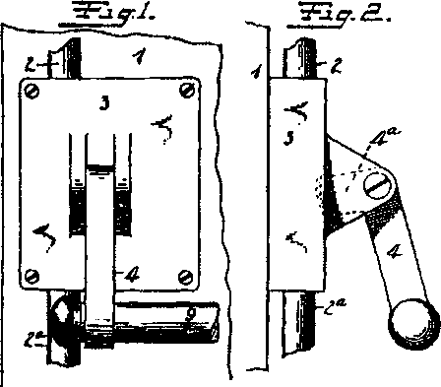

Mr. Voight undoubtedly was one of the most talented hard­ware inventors in the history of the American builders hardware industry His hardare career started with Russell & Erwin, and ended with Sargent and Co. Almost equally dividing his career between the two companies over a 66-year span, he received over 300 patents. His expertise covered the entire hardware spectrum, from door closers, to exit devices, to cylinders and locksets. His last efforts at Sargent were in the development of their post-WWII “Integralock.”

The following exit door device patent, 983011, dated January 31,1911, was issued while his was employed at Russell & Erwin.

Editor’s Note: Courtesy of The Builders Hardware Industry

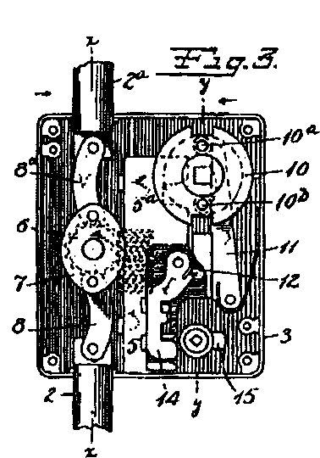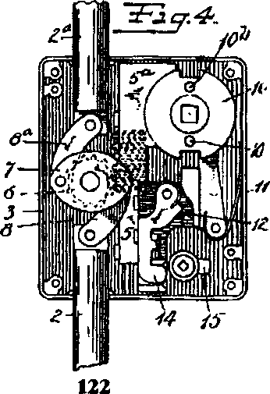

**144**

*ft*

Keynotes • March 2004

5/7*o, Nevada: In 1859, Charles Fuller built a log bridge across the Truckee River and charged a fee to ose who passed over it on their way to Virginia City and the gold recently discovered there. Fuller also ovided gold-seekers with a place to rest, purchase a meal, and exchange information with other rospectors.*

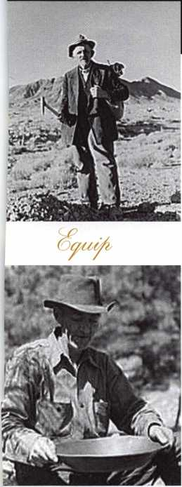

Keeping up with the latest the industry has to offer has never been more impor-  
tant for safe technicians. Time is of the essence when it comes to education. New  
developments spring up each year, making top-notch safe classes as good as gold  
in our ever-changing environment. The only chance to get world-class education  
and meet with the industry's top safe technicians and suppliers is the SAFETECH  
Convention and Trade Show. SAFETECH 2004 offers you a chance to explore your  
profession in ways you never thought possible. Register now to benefit from the  
future of this exciting industry.



cj^ tfAe a?u/ ixui/it cnc/udAy/

**SAFETECH 2004**

MARCH 21-27  
JOHN ASCUAGA'S  
NUGGET RESORT  
RENO, NEVADA



Now

**"I've lost my Taurus keys... can you make me a new set?'**

**How much of your money have you sent to the local Ford Dealer?**

NGS STAR XL CAN **Locksmith 8008LXLC**

**Did you Know...**

**...the Dealers charge an average of $100 per transponder key?**

**...you can get the factory transponder tool for less than the cost of doing one key per month?**

**Say "YES" to $100 phone calls.**

CAN VIM

**81201L**

**Use what the Dealers use for complete \**

**coverage on ALL Ford/Lincoln-Mercury and \**

**Mazda vehicles equipped with transponder keys. The NGS XL CAN offers complete transponder coverage including CAN protocol and the ability to clear ALL Diagnostic Service Codes**

*Cm*

**rou rve never ontyour own... rolliFreelfechnical Support ■Kll800-3^2-5080**

**2004 Software Update and CAN Vehi Interface Module now available.**

*msA*

**© Waekon/Hickok Inc. 2004 All rights reserved.**

